Sample text: Font Arial 12
970 Madison Oak Park Illinois 60302 ph: 708.524.3000 fax: 708.524.3019 www.op97.org

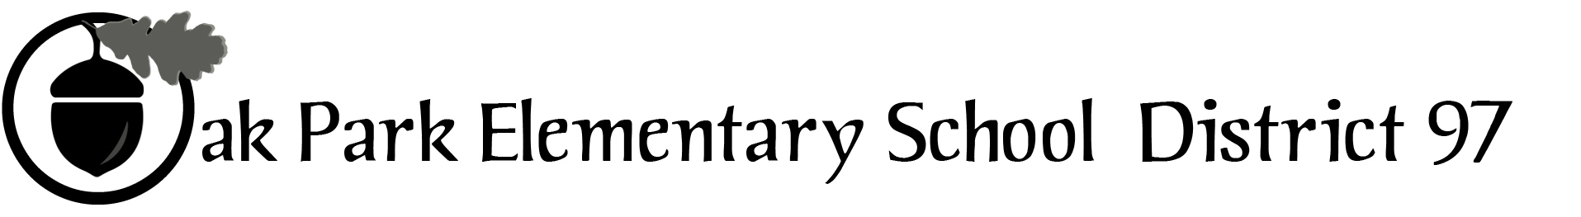

District 97 board member Liaison Report
This report was created and submitted by board members who serve as liaisons to board committees, administrative committees or community organizations. It is a brief summary of the committee or organization’s most recent meeting. It does not serve as or represent official minutes of that meeting.

Name of the committee/organization: OPEF

Date of the meeting: 3/16/16

Names of the District 97 board liaisons: Jim Gates

Names of the District 97 administrative representatives (if applicable): Faith Cole, John McCauley, and Helen Wei.

Brief summary/key outcomes of the meeting:
- Agenda was accomplished
- Base Camp updates
- Staszak Dinner planning
- New OPEF board member recruiting
- Revised discussion and approval of By-Laws

Next steps:
- Building 4/20/16 agenda

Questions/feedback for the District 97 board:
- Please support / attend the OPEF Staszak Dinner on Saturday, April 16 at the Oak Park Country Club
- OPEF will be seeking outside counsel related to OPEF policies regarding students with SPED services

Date of the next meeting: April 20, 2016
Supplemental documentation (e.g., agenda, reports, etc.) from the meeting (attached): Agenda on page 2

Report submitted by (include name and date): Jim Gates, 3/16/16

OUR MISSION: To provide innovative enrichment programs that have the greatest impact on District 97 students.

OUR MISSION: To provide innovative enrichment programs that have the greatest impact on District 97 students.

OUR MISSION: Mobilize community resources to provide innovative, hands-on learning experiences that have the greatest impact on District 97 students.

BOARD MEETING
Wednesday, March 16, 2016
7:00 p.m.

- Program Report – Spoken Word Program Coordinator Anne McNamee-Keels
- President’s Report – Karen Daily
- Approval of minutes from February 17, 2016
- Executive Director’s Report – Deb Abrahamson
- Communication & Development Director’s Report – Libbey Paul
- Treasurer’s Report – Steve Miller
- Committee Reports
  - Fundraising – Lisa Kitzman
  - D97 report – Carol Kelley/Jim Gates/Faith Cole/John McCauley
  - Governance – Willoughby Anderson
  - Strategy Task Force – Adam Golla
  - Marketing – Matt Cote
  - District 97 Links – Nora Flynn
- Old Business
- New Business

2015-16 Key Dates. Board meetings begin at 7 PM:

March 18, 2016: Spoken Word Julian/Brooks slam, 6 PM, School of Rock
April 20, 2016: board meeting
May 18, 2016: board meeting
June 15, 2016: board meeting
June 20 – July 15, 2016: BASE Camp

