Sample text: Font Arial 12
970 Madison Oak Park Illinois 60302 ph: 708.524.3000 fax: 708.524.3019 www.op97.org

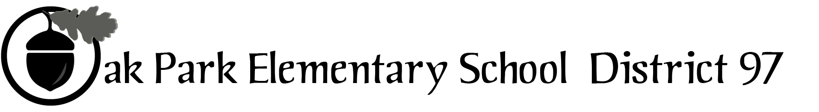

District 97 board member Liaison Report
This report was created and submitted by board members who serve as liaisons to board committees, administrative committees or community organizations. It is a brief summary of the committee or organization’s most recent meeting. It does not serve as or represent official minutes of that meeting.

Name of the committee/organization: PTO Council

Date of the meeting: September 26, 2016 at Lincoln Elementary

Names of the District 97 board liaisons: Graham Brisben

Names of the District 97 administrative representatives (if applicable): Superintendent Carol Kelley, Chief Business Officer Alicia Evans, Senior Director of Communications Chris Jasculca

Brief summary/key outcomes of the meeting: The meeting opened with introductions around the table, as this was the first meeting of this body since the start of the 2016-2017 school year. All schools were represented by their respective PTO leader(s). The group is chaired by Cynthia Hollis.

I provided a board report that highlighted some of the recent issues and activities of the board, including
- Approval of the new OPTAA agreement
- Budget approval pending for 9/27 meeting
- 2017-18 calendar
- New administration building
- ~$5MM expansion to Holmes and possible future capacity expansions needed at other buildings
- Downtown TIF agreement revision
- Upcoming April 2017 referendum

There was a good bit of group discussion around capacity expansions and the referendum.

Next, Chris Jasculca updated the group on several issues, including the district’s Webmaster position, CLAIM Legislator Night, and he also commented on the referendum.

Dr. Kelley then provided an update on her visioning process and the new district vision and goals for 2016-17. She also reported on the efforts to support teachers, including rollout of several new curricula programs and materials.

Dr. Evans reported on the 2016-17 budget and the contingency plans being developed for both passage and non-passage of the 2017 referendum. She also discussed with the group issues around insurance coverage for the PTOs.

Next steps: None.

Questions/feedback for the District 97 board: Interest was raised in making sure that the board was effective in communicating with the community about the upcoming referendum in April 2017.

Date of the next meeting: Monday, Oct. 24 at Brooks Middle School
Supplemental documentation (e.g., agenda, reports, etc.) from the meeting (attached):
None

Report submitted by (include name and date): Graham Brisben, 092716

