Sample text: Font Arial 12
970 Madison Oak Park Illinois 60302 ph: 708.524.3000 fax: 708.524.3019 www.op97.org

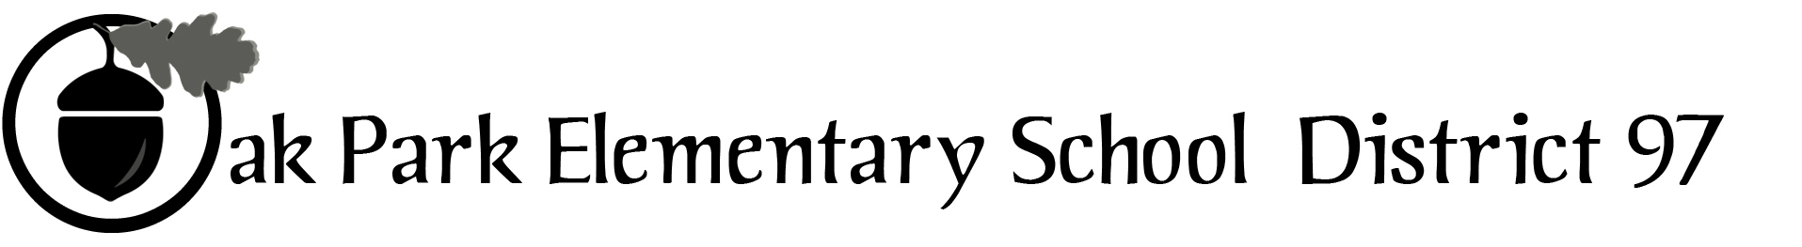

District 97 board member Liaison Report
This report was created and submitted by board members who serve as liaisons to board committees, administrative committees or community organizations. It is a brief summary of the committee or organization’s most recent meeting. It does not serve as or represent official minutes of that meeting.

Name of the committee/organization: CLAIM – Committee for Legislative Action, Intervention and Monitoring

Date of the meeting: May 19, 2016

Names of the District 97 board liaisons: Amy Felton and Rupa Datta

Names of the District 97 administrative representatives (if applicable): Chris Jasculca, Carol Kelley

Brief summary/key outcomes of the meeting:

Discussion Topics: Bob Spatz presented on the evidenced-based educational school funding model that ED-RED, IASB and many other organizations have been developing as an alternative to the funding model presented in SB231 (see attached executive summary).

The work teams for Equity and Excellence, Finance, Early Childhood and Events presented their updated draft position paper. Members approved the drafts. CLAIM will then send these position papers to the D97 Board for review and approval and ultimately hopes to use as a means to message and outreach to local legislators to educate them on the concerns of the committee and the District.

Next steps: CLAIM is in the process of drafting letters to local legislators to convey the district’s concerns about SB231. A draft letter will be submitted to the Board for it to consider/approve on an upcoming meeting.

Questions/feedback for the District 97 board: CLAIM is still interested in how it can be helpful to the board in its referendum planning process. To that end, CLAIM prepared and approved a list of questions for the board that it hopes the board will consider as it discusses the referendum at its upcoming meetings.

Date of the next meeting: Next CLAIM meeting is scheduled for Thursday, June 9, 2016.

Supplemental documentation (e.g., agenda, reports, etc.) from the meeting (attached): Agendas attached.

Report submitted by (include name and date): Amy Felton, May 25, 2016

