Sample text: Font Arial 12
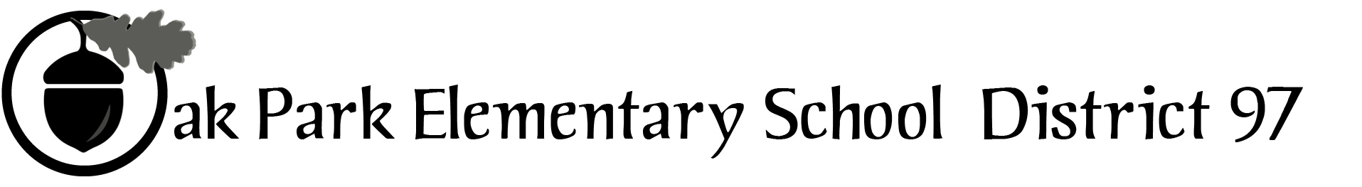

970 Madison Oak Park Illinois 60302 ph: 708.524.3000 fax: 708.524.3019 www.op97.org

District 97 board member Liaison Report
This report was created and submitted by board members who serve as liaisons to board committees, administrative committees or community organizations. It is a brief summary of the committee or organization’s most recent meeting. It does not serve as or represent official minutes of that meeting.

Name of the committee/organization: Community Engagement Core Planning Team (CPT)

Date of the meeting: 5/25/16

Names of the District 97 board liaisons: Rupa Datta and Jim O’Connor

Names of the District 97 administrative representatives (if applicable): Chris Jasculca and Superintendent Carol Kelley

Brief summary/key outcomes of the meeting:
- First we discussed the plan for tonight’s Superintendent’s Advisory Panel Meeting. The first step will be to see how the group approaches the frame of the work going forward: under four broad areas or two even broader areas. The remainder of the meeting will be to work in small groups to discuss what this work would look like under these agreed upon areas. The goal is to gather the small group notes at the end of the meeting and that will be input into the document that will be prepared for the board.
- We also talked about the staff present listening more than community members present.
- We also talked about how the report would be used by the district administration and board members to put together a longer-term plan. We also talked about how this would be communicated to the Superintendent’s Advisory Panel.
- Finally, we talked about the dates for Superintendent Kelly to present the initial draft of the report with the community on two dates in mid-June. We also discussed the ways that we could optimize a diverse group of people attending these meetings.

D97 Superintendent’s Advisory Panel Meeting
May 25th, 2016
Agenda

- Welcome! Overview & goals for tonight

- Discussion of the “Big Rocks”

- Dissection of the “Big Rocks”

