Sample text: Font Arial 12
970 Madison Oak Park Illinois 60302 ph: 708.524.3000 fax: 708.524.3019 www.op97.org

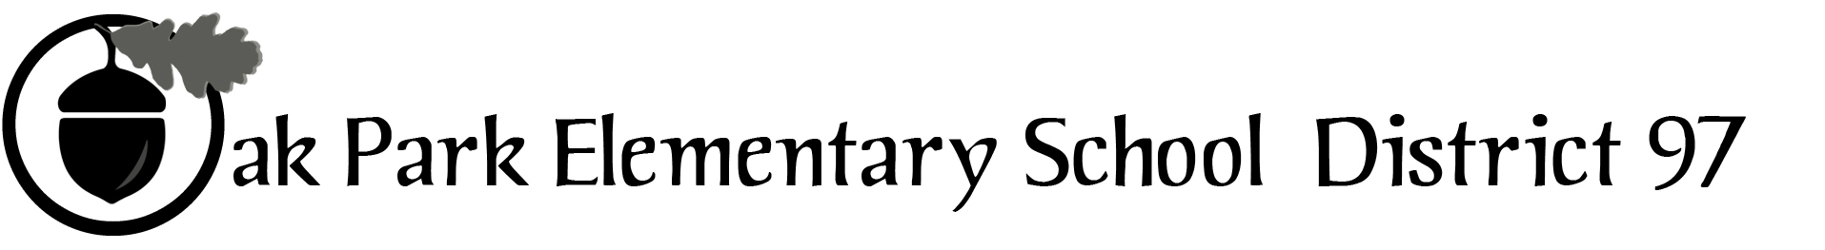

District 97 board member Liaison Report
This report was created and submitted by board members who serve as liaisons to board committees, administrative committees or community organizations. It is a brief summary of the committee or organization’s most recent meeting. It does not serve as or represent official minutes of that meeting.

Name of the committee/organization: OPEF

Date of the meeting: 5/18/16

Names of the District 97 board liaisons: Jim Gates

Names of the District 97 administrative representatives (if applicable): Faith Cole and Helen Wei

Brief summary/key outcomes of the meeting:
- Introduction of Shari Noland, new OPEF Marketing Director
- Architecture Adventure’s Adrienne McMullen reported that 880 3rd graders experienced various architectural projects this year
- The Staszack Dinner once again set a new record for net income
- OPEF met its goal for Base Camp scholarships as 80 scholarships will be provided
- OPRF and the Oak Park Food Pantry will provide lunch for Base Camp

Next steps: Further study and discussion

Questions/feedback for the District 97 board: None at this time

Date of the next meeting: June 15, 2016 in the Board Room
Supplemental documentation (e.g., agenda, reports, etc.) from the meeting (attached): Agenda on page 2

Report submitted by (include name and date): May 27, 2016

OUR MISSION: To provide innovative enrichment programs that have the greatest impact on District 97 students.

OUR MISSION: To provide innovative enrichment programs that have the greatest impact on District 97 students.

OUR MISSION: Mobilize community resources to provide innovative, hands-on learning experiences that have the greatest impact on District 97 students.

BOARD MEETING
Wednesday, April 18, 2016
7:00 p.m.

- Program Report – Architecture Adventure, Adrienne McMullen
- President’s Report – Karen Daily
- Approval of minutes from March 16 and April 20, 2016
- Executive Director’s Report – Deb Abrahamson
- Treasurer’s Report – Deb Abrahamson
- Committee Reports
  - Governance – Willoughby Anderson
  - Fundraising – Lisa Kitzman
  - Strategy Task Force – Adam Golla
  - District 97 Links – Nora Flynn
  - D97 report – Carol Kelley/Jim Gates/Faith Cole/John McCauley
  - Marketing – Matt Cote
- Old Business
- New Business

2015-16 Key Dates. Board meetings begin at 7 PM:
June 15, 2016: board meeting
June 20 – July 15, 2016: BASE Camp

