Sample text: Font Arial 12
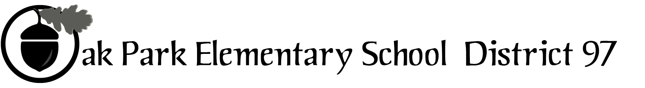
970 Madison Oak Park Illinois 60302 ph: 708.524.3000 fax: 708.524.3019 www.op97.org

District 97 board member Liaison Report
This report was created and submitted by board members who serve as liaisons to board committees, administrative committees or community organizations. It is a brief summary of the committee or organization’s most recent meeting. It does not serve as or represent official minutes of that meeting.

Name of the committee/organization: IGOV (Intergovernmental Committee)

Date of the meeting: December 3, 2016

Names of the District 97 board liaisons: Jim Gates

Names of the District 97 administrative representatives (if applicable): None assigned

Brief summary/key outcomes of the meeting:
- As was recommended by Dr. Evans, IGOV discussed establishment of separate IGOV account at Community Bank. IGOV recommended that the details related to the account e.g. fiscal or calendar year basis, funding and disbursement of payments, be left to the discretion of the governmental unit CFOs. J. Gates will meet with Dr. Evans to discuss this matter.
- IGOV set a tentative date of May 20, 2017 for its next assembly. Though details need to be finalized, preliminary discussions indicate topics will be equity and sustainability across the governmental units. As planning develops, IGOV will keep all boards apprised of developments.
- IGOV will recommend to the six intergovernmental units that IGOV host an informational workshop for all candidates who file for the April 4, 2017 Consolidated Election. Tentative dates for the candidates’ workshop are 1/21 or 1/28, 2017. As details are developed, IGOV will share draft details with each intergovernmental unit, seek input, and support for the concept.
Next steps:
- Share draft details of the Candidates’ Workshop concept with Board.
- J. Gates request meeting with Dr. Evans to discuss IGOV account.

Questions/feedback for the District 97 board:
- See above

Date of the next meeting:
- TBD
Supplemental documentation (e.g., agenda, reports, etc.) from the meeting (attached):
- IGOV agenda ( see page 2)

Report submitted by (include name and date): Jim Gates 12/4/16

IGOV: Intergovernmental Body of the Village of Oak Park

Saturday, December 3, 2016
9:00 AM Township Board Room
105 S. Oak Park Ave.

Meeting Plan

- Open
Present:
Absent:

- Review of notes: 11/13/16
- Around the Table Sharing
- Discussion topics
- IGOV bank account and reconciliation
- Assembly follow up and planning for the next assembly
- Candidates’ Workshop

- New business

- Next meeting

- Date: TBD
- Proposed Meeting Plan Items: TBD
- Member tasks to prepare for meeting: TBD
- Close:

