Sample text: Font Arial 12
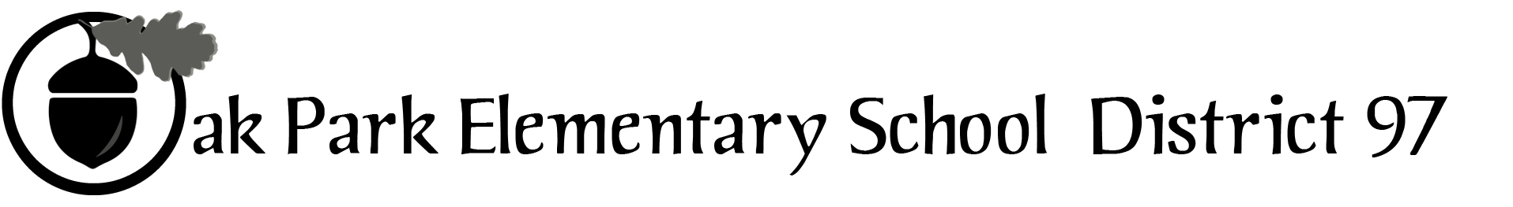

970 Madison Oak Park Illinois 60302 ph: 708.524.3000 fax: 708.524.3019 www.op97.org

District 97 board member Liaison Report
This report was created and submitted by board members who serve as liaisons to board committees, administrative committees or community organizations. It is a brief summary of the committee or organization’s most recent meeting. It does not serve as or represent official minutes of that meeting.

Name of the committee/organization: Community Engagement Core Planning Team (CPT)

Date of the meeting: 6/01/16

Names of the District 97 board liaisons: Jim O’Connor

Names of the District 97 administrative representatives (if applicable): Chris Jasculca and Superintendent Carol Kelley

Brief summary/key outcomes of the meeting:

We talked about the relationship between the 3 big rocks (below) and how to best build a discussion among the Superintendent’s Advisory Panel on 6/2.
#1 – Ensure all systems, structures and processes within District 97 reflect an understanding of what it means to educate the whole child and support the successful development of each and every student.
#2 – Create an equitable, inclusive and positive learning environment for all District 97 students.
#3 – Establish a comprehensive system of support for District 97 teachers.
We discussed the degree of specificity that would be helpful for the report to finally get to in its ultimate form.

We also talked about how a draft of the report from the Superintendent’s Advisory Panel will be in the board packet for the 6/14 board meeting. The presentation and discussion with the board will take place on 6/28 when more board members are present. We plan that on July 12th, the board would approve the finalized goals. The document will be posted at the districts website and open for public comment from 6/10 to 6/20. Superintendent Kelley plans to present a draft of report and discuss the report in “Community Conversations” on June 15th and 16th. We would use the final report document at the board retreat in August.

