Sample text: Font Arial 12
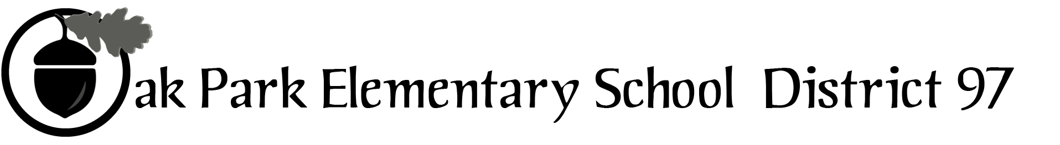
970 Madison Oak Park Illinois 60302 ph: 708.524.3000 fax: 708.524.3019 www.op97.org

District 97 board member Liaison Report
This report was created and submitted by board members who serve as liaisons to board committees, administrative committees or community organizations. It is a brief summary of the committee or organization’s most recent meeting. It does not serve as or represent official minutes of that meeting.

Name of the committee/organization: IGOV (Intergovernmental Committee)

Date of the meeting: March 19, 2016

Names of the District 97 board liaisons: Jim Gates and Bob Spatz

Names of the District 97 administrative representatives (if applicable): None assigned

Brief summary/key outcomes of the meeting:
- Discussion topics:
- Though not required by OMA, IGOV will keep Public Comment on its agendas
- Revised IGOV Mission Statement redraft
- Revised IGOV Informational Document historical section
- IGOV topics for October 2016 Assembly
- IGOV use of the FYI – six taxing bodies will appear in the right hand margin of FYI submissions.

Next steps:
- Lou Anne will send out a Doodle to scheduled next IGOV Meeting; minutes within 7 days
- Peter B. volunteered to meld the proposed topics into a draft to be shared at next IGOV
- Clarmarie and Jim T. will work on 2nd draft of IGOV mission statement
- Communicate IGOV interest in an FYI page, quarterly or as needed to our respective boards. Cost estimates below for 1 and 4 IGOV issues based on percentage of property tax share of total bill at $1,385.00 for 25,000 copies per issue:
Taxing Body % Share of Share for Share for
Total Tax Bill 1 Issue 4 Issues
- D97 41% $567.85 $2,271.44
- D200 27.2% $376.72 $1,506.88
- Library 6.9% $95.56 $383.84
- PDOP 6.0% $83.10 $332.40
- Township 1.8% $24.93 $99.72
- Village 17.1% $236.83 $947.32
Questions/feedback for the District 97 board:
- Thanks to Chris Jasculca, Senior Director of Policy, Planning and Communication for D97, for his help with obtaining FYI information.
- See bullet 2 above for direction from D97 Board and Administration for budget for D97 participation in IGOV FYI publication.

Date of the next meeting:
- TBD
Supplemental documentation (e.g., agenda, reports, etc.) from the meeting (attached):
- IGOV agenda ( see page 2)

Report submitted by (include name and date): Jim Gates and Bob Spatz, 3/24/16

Intergovernmental Committee of the Village of Oak Park

Saturday, March 19, 2016
9:00 AM Township Board Room
105 S. Oak Park Ave.

Meeting Agenda

- Call to Order:
Present:
Absent:
2. Approval of Agenda:
3. Approval of Minutes: February 20, 2016
4. Public Comment: (Let’s discuss this agenda item)
5. Around the Table Taxing Body Updates
6. Follow up from 2/20/16:
- Discussion of revised IGOV mission statement
- Discussion of topics for October 2016 assembly
- Discussion of IGOV page in FYI
- Discussion of IGOV logo using all 6 taxing body logos
7. Next Meeting Related:
- Date
- Agenda Items
- Volunteer Member Tasks.
8. Adjournment:

