Sample text: Font Arial 12
970 Madison Oak Park Illinois 60302 ph: 708.524.3000 fax: 708.524.3019 www.op97.org

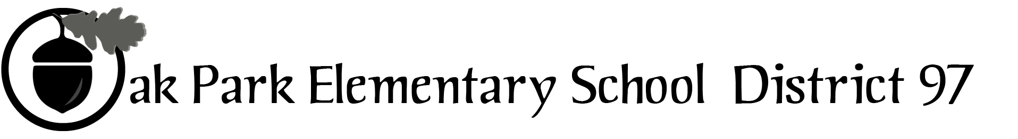

District 97 board member Liaison Report
This report was created and submitted by board members who serve as liaisons to board committees, administrative committees or community organizations. It is a brief summary of the committee or organization’s most recent meeting. It does not serve as or represent official minutes of that meeting.

Name of the committee/organization: IGOV (Intergovernmental Committee)

Date of the meeting: February 20, 2016

Names of the District 97 board liaisons: Jim Gates and Bob Spatz

Names of the District 97 administrative representatives (if applicable): None assigned

Brief summary/key outcomes of the meeting:
- Post mortem of 3rd Annual IGOV Assembly of Governing Boards

Next steps:
- Revise IGOV mission
- Set upcoming assembly dates: October 2016, May 2017 (post elections), January 2018, October 2018
- Develop topics for the next agenda
- Revise assembly agenda / format based on Table Notes from 1/23/16 assembly

Questions/feedback for the District 97 board:
- IGOV is considering a page in the FYI. IGOV would like to ask the information officers of the 6 taxing bodies to suggest how IGOV could best utilize the FYI as a community engagement tool: format, content, etc. IGOV would also like the information officers for suggestions on how to format all 6 taxing body logos in one shape as a way to brand IGOV. This is not a request for an IGOV logo.
- IGOV would like to ask Chris Jasculca to provide the following: cost of 1 and 2 sided inserts in the FYI; the upcoming text submission and publication dates for 2016.

Date of the next meeting:
- March 19, 2016
Supplemental documentation (e.g., agenda, reports, etc.) from the meeting (attached):
- IGOV agenda ( see page 2)

Report submitted by (include name and date): Jim Gates and Bob Spatz, 2/26/16

Intergovernmental Committee of the Village of Oak Park

Saturday, February 20, 2016
9:00 AM Township Board Room
105 S. Oak Park Ave.

Meeting Agenda

1. Call to Order
2. Approval of Agenda
3. Approval of Minutes
4. Public Comment
5. Review of 1/23/16 IGOV Assembly (Plus / Delta Comments Process, format, etc.)
- Review of last assembly Table Notes (Reactions, next steps, etc.)
- Review of replies to post card comments from community members
- Topics / possible date for the next assembly
- Other
  - IGOV meeting treats going forward
  - Consideration of a revised IGOV image (Agendas, FYI, etc.) *
  - Report from Participating Taxing Bodies
  - Next meeting date
  - Adjournment

