Sample text: Font Arial 12
970 Madison Oak Park Illinois 60302 ph: 708.524.3000 fax: 708.524.3019 www.op97.org

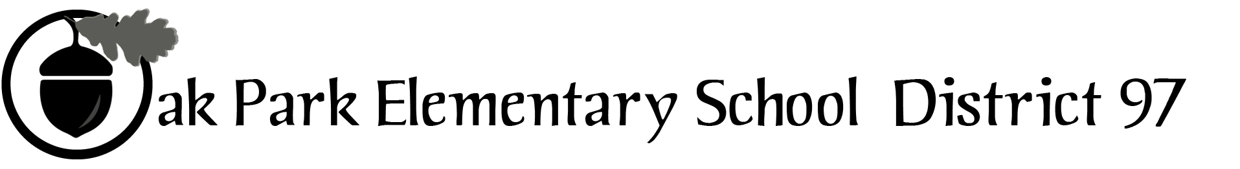

District 97 board member Liaison Report
This report was created and submitted by board members who serve as liaisons to board committees, administrative committees or community organizations. It is a brief summary of the committee or organization’s most recent meeting. It does not serve as or represent official minutes of that meeting.

Name of the committee/organization: Collaboration IGA Governing Board

Date of the meeting: September 28, 2016 (see attached agenda)

Names of the District 97 board liaisons: Rupa Datta, Bob Spatz,

Names of the District 97 administrative representatives (if applicable): Carol Kelley (not present)

Brief summary/key outcomes of the meeting:
Contractually required report on 2015-2016 measures update was provided (and is attached). Signed permission from the State of Illinois for Chapin Hall access to selected data sources (Medicaid, Early Intervention, etc.) was finally received at the end of August. This is a major step forward.

Financial reports were presented. Primarily due to the change in home-visiting vendors (from Parenthesis to Easter Seals), there was underspending last year. A remittance will again be returned to the Collaboration account held by the jurisdictions. The relationship with Easter Seals has begun very positively. The Collaboration plans some outreach to New Moms, the new parent organization for Parenthesis.

D97 has declined to participate in the EDI fielding in early January 2017. The district has expressed general support for the effort and is open to discussing alternative timing for potential participation if feasible. Collaboration staff will work with D97 administration to determine next steps, if any. The IGA Board voted to approve funds for compensation of teacher training time if the EDI proposal does move forward. Some IGB members expressed disappointment at D97’s reluctance to participate within the timeframe requested by Erickson.

[Updated provided 9/29/16: the Collaboration has been notified of a significant grant award from the Grand Victoria Foundation.]

Discussion Topics:
Plan for November Tri-Board meeting was discussed.

Next steps:
Collaboration staff and D97 administration will discussion the EDI RFP.
D97 will provide an administrative update on the Collaboration account, including details on payment of a substantial outstanding invoice due to the Collaboration.

Questions/feedback for the District 97 board: Please let Rupa or Bob know if you have suggestions for the Tri-Board meeting agenda.

Date of the next meeting: Tri-board meeting November 30th.

Supplemental documentation (e.g., agenda, reports, etc.) from the meeting (attached): Materials attached.

Report submitted by (include name and date): Rupa Datta, September 29, 2016,

