970 Madison Oak Park Illinois 60302 ph: 708.524.3000 fax: 708.524.3019 www.op97.org

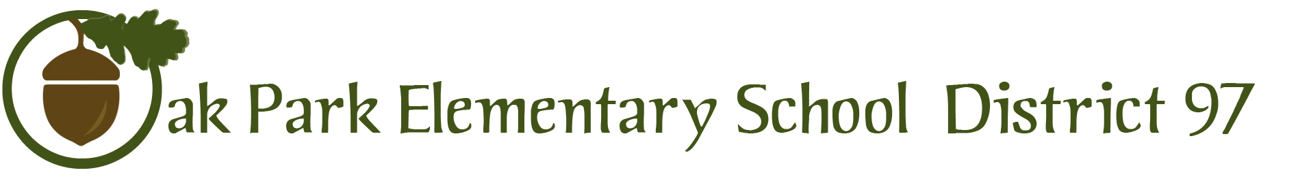

TO: Members, Board of Education
Dr. Carol Kelley, Superintendent

FROM: Dr. Carrie Kamm, Director of Curriculum and Instruction

DATE: March 17, 2016

RE: K-5 Science Curriculum Program Update Order for Next Generation Science Standards/Illinois Science Learning Standards transition-updated memo

The Illinois Learning Standards in Science became effective in February 2014 and are based on the Next Generation Science Standards (NGSS). The standards serve as a guide for what students should know and be able to by the end of each grade level. The full implementation of the standards are set for the 2016-2017 school year. To prepare for this transition, our K-5 teachers have participated in professional learning on the architecture of NGSS standards, using science notebooks to support student thinking, and the place of argument (claim, evidence, and reasoning) in the NGSS.

To insure that our K-5 science program meets the new Illinois Learning Standards in Science, I recommend that we update our current FOSS (Full Option Science System) materials and purchase the NGSS edition of the instructional kits. Through discussion with our district science consultant,Dr. Anne Reichle, I do not recommend reviewing other programs at this time. The market place is still in flux as materials are adapted and aligned to the NGSS. Only 9 states have adopted NGSS, which has resulted in few companies making the shift to inquiry-based programs that connect with the NGSS. Delta Education, the FOSS publisher, is one of the few companies that have moved forward with creating an inquiry-based program that is aligned with the NGSS. The current textbook-oriented programs are likely not going to support teacher’s efforts at meeting the performance expectations identified in the new Illinois Learning Standards in Science. The new Illinois Learning Standards in Science require students to engage in science practices, which is not something easily supported with a textbook-oriented program. While no program is perfect, from conversations with Dr. Reichel, we have determined that the FOSS-NGSS program offers the deepest conceptual flow and engages students in science practices. The program’s science notebook component is strong, all materials are available online, materials are available in Spanish, and there are online tutorials for students who miss lessons. Teachers in District 102 (Aptakisic Trip) are using the FOSS-NGSS program this year and report ease of use because of the embedded teacher instructional videos, students are engaged in science instruction, and the use of science notebooks is supporting student understanding of writing for argument and beyond a traditional science lab report.

Given that our teachers are familiar with the FOSS-NGSS program, our professional learning efforts will focus on understanding the new Illinois Learning Standards in Science and integrating CCSS ELA writing standards through the use of Science Notebooks. Please see the attached quote for updating our K-5 science materials for your review.

Sincerely,

Dr. Carrie Kamm

