Sample text: Font Arial 12
970 Madison Oak Park Illinois 60302 ph: 708.524.3000 fax: 708.524.3019 www.op97.org

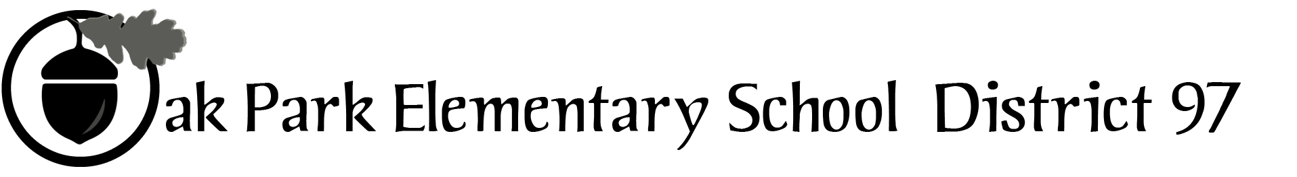

District 97 board member Liaison Report
This report was created and submitted by board members who serve as liaisons to board committees, administrative committees or community organizations. It is a brief summary of the committee or organization’s most recent meeting. It does not serve as or represent official minutes of that meeting.

Name of the committee/organization: OPEF

Date of the meeting: 2/17/16

Names of the District 97 board liaisons: Jim Gates

Names of the District 97 administrative representatives (if applicable): Helen Wei and John McCauley

Brief summary/key outcomes of the meeting:
- Mary Beth Hausken reviewed VEX Robotics program
- Executive Director’s Report – Deb Abrahamson led a discussion of base camp scholarships and the OPEF is actively working with D97 to recruit more F/R students

Next steps: Further study and discussion

Questions/feedback for the District 97 board: None at this time

Date of the next meeting: March 16, 2016
Supplemental documentation (e.g., agenda, reports, etc.) from the meeting (attached): Agenda on page 2

Report submitted by (include name and date): Jim Gates, 2/17/16

OUR MISSION: To provide innovative enrichment programs that have the greatest impact on District 97 students.

BOARD MEETING
Wednesday, February 17, 2016
7:00 p.m.

- Program Report – VEX Robotics Program Coordinator Mary Beth Hausken
- President’s Report – Karen Daily
- Approval of minutes from January 20, 2016
- Executive Director’s Report – Deb Abrahamson
- Communication & Development Director’s Report – Libbey Paul
- Treasurer’s Report – Steve Miller
- Committee Reports
  - Strategy Task Force – Adam Golla
    - Approval of revised mission, vision, values
  - Marketing – Matt Cote
  - Fundraising – Lisa Kitzman
  - District 97 Links – Nora Flynn
  - D97 report – Carol Kelley/Jim Gates/Faith Cole/John McCauley
- Old Business
- New Business

2015-16 Key Dates. Board meetings begin at 7 PM:
February 27, 2016: OPEF Open House, Beye School
March 16, 2016: board meeting
March 18, 2016: Spoken Word Julian/Brooks slam, 6 PM, School of Rock
April 16, 2016: William C. Staszak Benefit
April 20, 2016: board meeting
May 18, 2016: board meeting
June 15, 2016: board meeting
June 20 – July 15, 2016: BASE Camp

