Sample text: Font Arial 12
970 Madison Oak Park Illinois 60302 ph: 708.524.3000 fax: 708.524.3019 www.op97.org

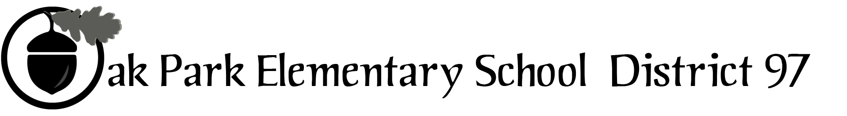

District 97 board member Liaison Report
This report was created and submitted by board members who serve as liaisons to board committees, administrative committees or community organizations. It is a brief summary of the committee or organization’s most recent meeting. It does not serve as or represent official minutes of that meeting.

Name of the committee/organization: Oak Park Education Foundation board

Date of the meeting: November 16, 2016 (see attached agenda)

Names of the District 97 board liaisons: Rupa Datta

Names of the District 97 administrative representatives (if applicable): Helen Su, John McCauley (Holmes), John Hodge (Irving)

Brief summary/key outcomes of the meeting: I was unable to attend the meeting.

Discussion Topics: Last meeting for Exec Dir.

Next steps: None.

Questions/feedback for the District 97 board: None

Date of the next meeting: January 18, 2017

Supplemental documentation (e.g., agenda, reports, etc.) from the meeting (attached): Materials attached.

Report submitted by (include name and date): Rupa Datta, November 21, 2016

