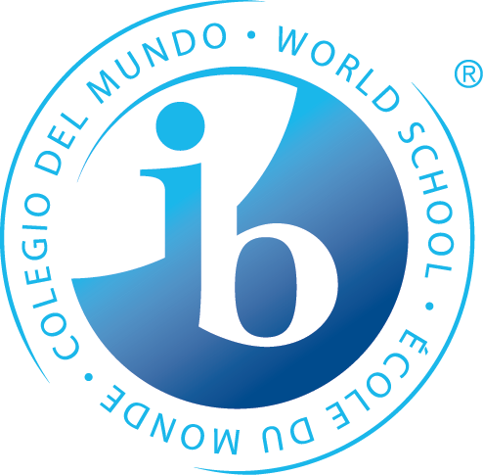
What is Happening During the 2nd Trimester of 6th Grade?

Statements of Inquiry

The IB MYP emphasizes the power of “the big picture.” This means that teachers work to collaboratively develop a single, central statement for each unit that captures and reflects what’s so important about what students are learning – this is called the statement of inquiry. This statement represents the greater learning our students achieve through our content, leaving a permanent mark of greater knowing and understanding that will continue to develop throughout their lives.

Language A

When communication is imagined with purpose behind the structure, it results in powerful self-expression.

Math

Unit One - To make logical, balanced decisions, we identify and simplify the situation.

Unit Two - Social entrepreneurs will identify the system that represents the relationship between known and unknown information.

Unit Three - Finding balanced solutions can be achieved by following logical processes of simplification.

Science

Unit One - Scientists use models to represent the movement of matter and energy throughout ecosystems.

Unit Two - A population’s diversity and interconnections are impacted through relationships and interactions.

Humanities

Unit One - Scientific and Technological changes impact politics, economics and culture.

Unit Two - If a culture can successfully use and control its environment, that culture can become a globally dominant force through trade or conquest in that region.
simplification.

Years from now, when the dates, formulas and facts have all but disappeared, what remains? Through the hard work, collaboration, and deep thinking of our teachers…our statements

PE/Health

Unit One – Students make choices to try to make a positive change in their fitness levels.

Unit Two – The relationship and interactions we have with one another and our choices affect our successfulness.

Language B

French:
Unit One - Interactions with others can have different meanings leading to diverse messages.

Unit Two - The purpose of understanding people’s likes & dislikes is to allow us to connect with others.

Spanish:
Unit One - Talking to others about your school experiences can build connections and stronger peer-to-peer relationships.

Unit Two - Dietary and lifestyle choices vary within the context of culture

Arts

Visual Arts:
The connections we make between different cultures and social constructs and our personal philosophies help us to create a new visual culture.

Performing Arts:
Unit One - The development of voice/performance building will lead to musicians who understand the relationship between technique and healthy singing/performing.

Unit Two - Rhythms communicate a composer’s intent to provide you with information to correctly play and then later compose your own music.

Speech, Drama & Debate:
Unit One - The composition of identities and relationships changes with theatrical interpretation.

Unit Two - Interpretation of literature takes form through actor and audience personal and cultural expression.

Design

Human development combined with innovation and evaluation, develops solutions to solve or satisfy human needs or wants.
*Some students may take this course Tri. 1 or 3

Years from now, when the dates, formulas and facts have all but disappeared, what remains? Through the hard work, collaboration, and deep thinking of our teachers…our statements of inquiry will!

