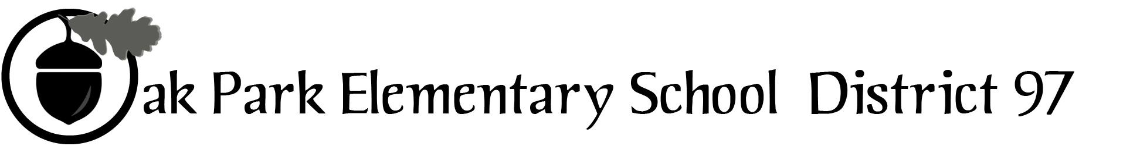
Sample text: Font Arial 12
260 Madison Oak Park Illinois 60302 ph: 708.524.3000 fax: 708.524.3019 www.op97.org

DISTRICT 97 BOARD MEMBER LIAISON REPORT
This report was created and submitted by board members who serve as liaisons to board committees, administrative committees or community organizations. It is a brief summary of the committee or organization’s most recent meeting. It does not serve as or represent official minutes of that meeting.

Name of the committee/organization: CLAIM

Date of the meeting: 6/08/17

Names of the District 97 board liaisons: Jim O’Connor and Katherine Murray-Liebl

Names of the District 97 administrative representatives (if applicable):

Brief summary/key outcomes of the meeting: Mr. Brian Battle, Executive Director of ED-RED and Barrington District 200 President, gave a presentation on the evidence-based school funding formula and its status in Springfield. He shared information about adequate funding and equitable distribution of general state aid. According to Mr. Battle, the funding formula is widely accepted; however, there is not agreement when it comes to how CPS is handled within the formula (block grant, pensions, etc.) SB 1, which follows the evidence-based school funding formula, has passed both chambers, but is currently being held on a motion to reconsider. SB 1 faces an uncertain future unless details of how CPS will be handled are worked out. Also, with no state budget, nothing can move forward with this bill.

According to Battle, Oak Park will most likely not lose funding with the new formula.

CLAIM did not hold a regularly scheduled meeting after the presentation because it did not have a quorum.

Next steps:

Questions/feedback for the District 97 board:

Date of the next meeting: July 13, 2017
Supplemental documentation (e.g., agenda, reports, etc.) from the meeting (attached):

Report submitted by (include name and date): Katherine Murray Liebl, 6/13/17

