Sample text: Font Arial 12
970 Madison Oak Park Illinois 60302 ph: 708.524.3000 fax: 708.524.3019 www.op97.org

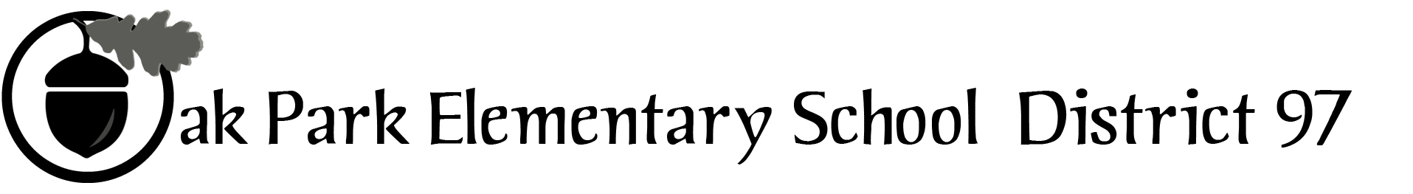

District 97 board member Liaison Report
This report was created and submitted by board members who serve as liaisons to board committees, administrative committees or community organizations. It is a brief summary of the committee or organization’s most recent meeting. It does not serve as or represent official minutes of that meeting.

Name of the committee/organization: COG (Council of Governments)

Date of the meeting: April 6, 2016 7:30-8:45 AM

Names of the District 97 board liaisons: Jim Gates

Names of the District 97 administrative representatives (if applicable): None assigned

Brief summary/key outcomes of the meeting:
- The Village shared its perspective on taxing body partnerships related to economic development on Lake and Madison Streets.
- A representative from each taxing body board presented updates on a variety of topics. (Because a primary function of COG is to share information with it fellow boards, see page 2 for a summary of the updates.)

Next steps:
- June 1, 2016 meeting

Questions/feedback for the District 97 board:
- The Village Board will respond to a cover letter and questions related to Lake Street development within 5 business days.

Date of the next meeting (and all of 2016):
- 2/3/ 2016, 4/6/2016, 6/1/2016, 8/3/2016, 10/5/2016, 12/7/2016.
Supplemental documentation (e.g., agenda, reports, etc.) from the meeting (attached):
- COG agenda ( see page 2)
- Updates summaries (see page 2)

Report submitted by (include name and date): Jim Gates, April 7, 2016

Village of Oak Park
Meeting Agenda
COG (Council of Governments)

Wednesday, April 6, 2016 7:30 AM OPRFHS Board Room 213

Agenda
- Roundtable Updates*
- TIF
- Adjournment
Updates*
D200 - Jeff Weissglass and Dr. Isoye:
- Update on pool meetings and discussions
- Commitment to excellence and equity, and in particular, as it relates to race

Library – Jim Madigan and David Seleb:
- OPL has representatives at this week’s Public Library Conference is Denver, CO
- Hacking Hemingway Grant partnership with D97 is moving forward
- A capital asset survey will soon be in process
- On April 13, the Library will host a “ Meet and Match” designed to bring community volunteers and over 30 community organizations together

Township - David Boulanger and Gavin Morgan:
- Underage drinking grant is moving forward slowly
- Youth Interventionist IGA was mentioned

Park District: Jan Arnold and Paul Ascheleman:
- Julian and Brooks outdoor space and field ribbon cutting on 4/9
- Maple Park will be closed for Phase II renovations from July to November
- A 2015-16 Civic Center Feasibility study update was provided: AM and evening focus groups with a broad spectrum of the community resulted in positive feedback for the concept and an invitation was extended to the PDOP (Park District of Oak Park) Community Meeting on April 27 from 5:00-8:00 PM at Cheney Mansion where attendees will meet and talk with representatives of Sink, Combs, & Dethlefs
- The Austin Gardens Environmental Education Center will be a LEED Platinum project ribbon cutting in June 11
Village – Anan Abu-Taleb, Cara Pavletich, Bob Tucker
- The Village will enact legislation to make the legal age to buy tobacco products in Oak Park to age 21
D97 – Carol Kelly:
- New CFO and searches for HR Director, CAO, and Holmes principal
- Dr. Kelly’s 100 Day Report
- PARCC testing this week
- Superintendent’s Advisory Panel
D97 – Jim Gates:
- IGOV mission change from advisory body to assembly facilitation on a 3 assemblies per 2 year cycle
- IGOV will be submitting articles to FYI on a quarterly basis
- Board study and examination of community engagement practices

