Sample text: Font Arial 12
260 Madison Oak Park Illinois 60302 ph: 708.524.3000 fax: 708.524.3019 www.op97.org

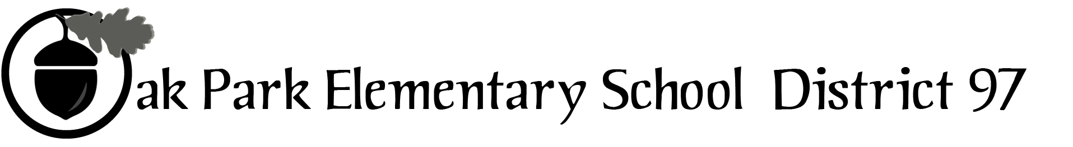

District 97 board member Liaison Report
This report was created and submitted by board members who serve as liaisons to board committees, administrative committees or community organizations. It is a brief summary of the committee or organization’s most recent meeting. It does not serve as or represent official minutes of that meeting.

Name of the committee/organization: Committee for Citizen Engagement

Date of the meeting: October 5, 2017

Names of the District 97 board liaisons: Rob Breymaier, Rupa Datta

Names of the District 97 administrative representatives (if applicable): Chris Jasculca, Lou Anne Johannesson

Brief summary/key outcomes of the meeting:
- The committee chair Leslie Truelove recapped the presentation she made at the last board meeting. We discussed the role of CCE in formulating a strategy for communicating with the understanding that CCE identified that “Proactive Response” is an ideal form of communication with the community.
- CCE asked the question: “What does success look like?” We settled on CCE identifying 3-5 community engagement activities for the board. Sample ideas included Town Halls, Coffee/Office Hours by board members, and being available for questions at school events (i.e. Fun Fairs and other high attendance events).
- Meanwhile, we also identified that we should communicate the difference between the roles of the board and the administration as well as the difference between the board and the district as a whole. This could be one of the topics for an identified activity by CCE.
- We also discussed how other committees could connect with CCE to help provide the data necessary for communication such as FORC, FAC, and CLAIM. Each has important information to be communicated to the community. FORC and FAC have already requested cooperation as well.
- A couple of one-pagers were suggested around how we are following through on spending for the referenda, particularly the CapEx referendum.

Next steps: We discussed being available for the CLAIM meeting on November 1 and to hopefully have some of the materials CCE could provide available.

Questions/feedback for the District 97 board:

Date of the next meeting:
Supplemental documentation (e.g., agenda, reports, etc.) from the meeting (attached): N/A

Report submitted by (include name and date): Rob Breymaier, October 9, 2017

