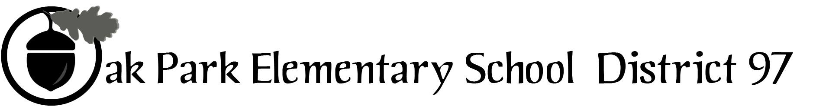
Sample text: Font Arial 12
260 Madison Oak Park Illinois 60302 ph: 708.524.3000 fax: 708.524.3019 www.op97.org

DISTRICT 97 BOARD MEMBER LIAISON REPORT
This report was created and submitted by board members who serve as liaisons to board committees, administrative committees or community organizations. It is a brief summary of the committee or organization’s most recent meeting. It does not serve as or represent official minutes of that meeting.

Name of the committee/organization: CLAIM

Date of the meeting: July 13, 2017

Names of the District 97 board liaisons: Katherine Murray-Liebl and Jim O’Connor(absent)

Names of the District 97 administrative representatives (if applicable): Felicia Starks-Turner (absent) and Chris Jasculca(absent)

Brief summary/key outcomes of the meeting:
- CLAIM hopes to have its annual legislator’s forum either the second or third week of October
- Felicia Starks-Turner and Deacon Wiley will take the lead for the Equity and Excellence workgroup for CLAIM (Neither were present for the July 13th meeting, but others shared this info)
- Funding for evidence-based model is in limbo currently. In the spending plan that was recently approved, Illinois can't appropriate money for schools unless a new funding formula also wins approval. K-12 dollars are tied to this. Some school districts may be unable to open on time if an agreement is not reached. The opening of D97 should not be affected by the delay.

Next steps:

Questions/feedback for the District 97 board:
- Is the board interested in asking the CLAIM Early Childhood workgroup to focus on any one particular area during this upcoming school year?
- Are we communicating with neighboring districts about the charter school that plans to open in our area?
- Does District 97 have a formal application process for charter schools to follow?
- How will the new Senior Director of Equity use the ESSA framework as it relates to D97?
- Have changes been made to the PKP program? When was this decided? To whom was it communicated and how? Was the board aware of this change? (Most notable change being that siblings no longer qualify for PKP automatically)
- Would we like to ask Karen Yarborough and Carolyn Newberry Schwarz to come and present to the board about changes in Early Childhood in Illinois (Boost to block grant, who qualifies, how OP could benefit/use funds, etc)

Date of the next meeting: September 14, 2017
Supplemental documentation (e.g., agenda, reports, etc.) from the meeting (attached):
Agenda attached
Report submitted by (include name and date):
Katherine Murray-Liebl
July 21, 2017

