Sample text: Font Arial 12
970 Madison Oak Park Illinois 60302 ph: 708.524.3000 fax: 708.524.3019 www.op97.org

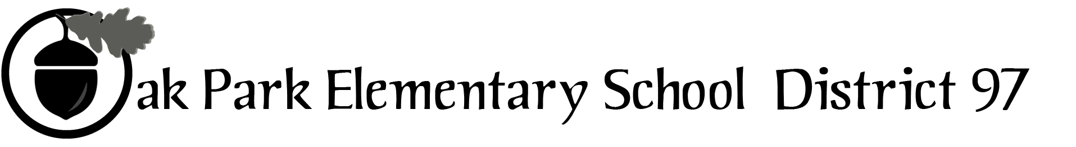

District 97 board member Liaison Report
This report was created and submitted by board members who serve as liaisons to board committees, administrative committees or community organizations. It is a brief summary of the committee or organization’s most recent meeting. It does not serve as or represent official minutes of that meeting.

Name of the committee/organization: Citizens Council

Date of the meeting: September 15, 2016 (see attached agenda)

Names of the District 97 board liaisons: Amy Felton and Graham Brisbane

Names of the District 97 administrative representatives (if applicable): None.

Brief summary/key outcomes of the meeting:

Discussion Topics: Ideas for discussion topics/speakers for meetings during the 2016-2017 year (see attached). Please note that all D97 board members are always welcome at any of the Citizen Council meetings.

Next steps: None.

Questions/feedback for the District 97 board: None.

Date of the next meeting: October 13, 2016, and November 10, 2016

Supplemental documentation (e.g., agenda, reports, etc.) from the meeting (attached): Agenda and May 2016, and September 2016, meeting minutes attached.

Report submitted by (include name and date): Amy Felton, November 22, 2016

