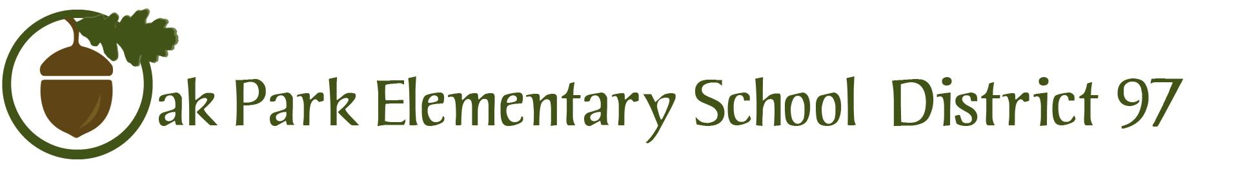

260 Madison Oak Park Illinois 60302 ph: 708.524.3000 fax: 708.524.3030 www.op97.org

To: District 97 Board of Education
Dr. Carol Kelley, Superintendent of Schools

From: Dr. Eboney Lofton, Chief Academic and Accountability Officer
Dr. Tawanda Lawrence, Senior Director of Curriculum, Instruction and Assessment
Faith Cole, Director of Multi-Tiered Systems of Support

Re: D97 2019 Summer Program Summary & D97 Summer Program 2020 Recommendations
Board of Education Report

Date: December 10, 2019

Type of Report: Informational

Purpose of Report: The purpose of this report is to provide the Board of Education with a summary of the district’s 2019 summer programs and recommendations for Summer 2020 programming for grades K-8. The information in this report is divided into two parts.
- PART ONE: 2019 Summer Program Summary includes the following four sections:
  - Summer Launch (K-8)
  - Newcomer EL Summer Program (1-8)
  - Middle School Summer Math Enrichment (6-8)
  - Summer Music Camp (5-8)
  - Extended School Year Program (EC - 7)
  - Community Partnerships

- PART TWO: 2020 Summer Program Recommendations includes the following five sections:
  - D97 2020 Summer Program Schedule
  - Summer Launch Student Selection Criteria
  - 2020 Summer Program Recommendations
  - Proposed Timeline
  - Proposed Budget

Introduction:

District 97 provides a variety of summer programming that reflects our district’s vision to create a positive learning environment for all students that is equitable, inclusive, and focused on the whole child. Our summer programming also contributes to helping all of our students experience or achieve the following goals:
- Known, nurtured, and celebrated LEARNER
- Empowered and passionate SCHOLAR
- Confident and persistent ACHIEVER
- Creative CRITICAL THINKER & GLOBAL CITIZEN

PART ONE: 2019 Summer Program Summary

The summer programming offered in 2019 included five programs:
- Summer Launch (K-8)
- Newcomer EL Summer Program (1-8)
- Middle School Summer Math Enrichment (6-8)
- Summer Music Camp (5-8)
- Extended School Year Program (EC - 7)

Summer Launch (Incoming K-8 students):
Summer Launch was located at two schools this summer, June 17 through July 12, 2019. The table below provides more details for each program, including the incoming grade levels of participating students, location, program focus and hours, entry criteria, student placement into classes/camps, and community partnerships.

Summer Launch
June 17 - July 12, 2019
Monday through Friday
Incoming Grade Levels of Participating Students | Grades K - 4 | Grades 5 - 8
Location | Holmes | Julian
Program Focus | Reading/Writing Workshop  Math Enrichment | AUTOROBO STEAM (reading, mathematics, and engineering)
Program Hours | 8:00 a.m. - 12:00 p.m. | 8:00 a.m. - 12:00 p.m.
Extended Hour Opportunities | Park District of Oak Park  Optional afternoon day camp and extended day  - Day Camp at Holmes: 12:00 p.m. - 3:00 p.m.  - Extended Day at Holmes: 3:00 p.m. - 6:00 p.m.
Entry Criteria | Students identified as needing Tier 3 interventions through the school-based Multi-Tiered Systems of Support process
Community Partnerships | - Park District of Oak Park (PDOP)  - Oak Park Public Library (OPPL)  - Beyond Hunger (Formerly Oak Park River Forest Food Pantry)  - Equity Team Inc. (E-Team)

Students invited to participate in the Summer Launch program were identified by their home schools as needing and receiving Tier 3 interventions and support after winter 2018 testing. This year, we extended invitations to English Learner students who scored 2.5 to 3.0 on ACCESS. We invited a total of 300 students and had a total of 142 incoming K-8 students enrolled in Summer Launch at the beginning of the program.

Due to no-shows or inconsistent attendance, 136 students completed the 2019 Summer Launch program with at least 75% attendance and are still enrolled in D97 schools. We would like to highlight that this summer, student enrollment with at least 75% attendance increased by 16 students in grades K-4 and 6 students in grades 5-8.

Summer Launch Student Enrollment with at least 75% Attendance Over Time

 | Kindergarten-4th grade | 5th-8th grade
Enrollment –  Summer Launch 2019 | 106 | 30
Enrollment –  Summer Launch 2018 | 90 | 24
Enrollment –  Summer Launch 2017 | 103 | 64

In the next sections, we will discuss the K-4 Summer Launch program and evaluation followed by the 5-8 Summer Launch program.

K-4 Summer Launch:
K-4 Summer Launch Staffing
We hired one coordinator and 12 teachers for the K-4 Summer Launch program. An open application was sent to all D97 teachers. We considered the following factors in our hiring process:
- application questions/responses
- grade currently teaching
- past experience with Reading Units of Study and Writing Units of Study and Eureka Math
- principal recommendations and feedback

The following is a list of our selected staff for the K-4 program:
- Coordinator: Marquita Rogers, Irving

- Teachers:
  - Rebecca Meilinger, Lincoln
  - Mary Kelly, Irving
  - Virginia Nagano, Lincoln
  - Nicole Decancq, Lincoln
  - Faith Harris, Holmes
  - Jennifer Logan, Beye
  - Mohogany Williams, Irving
  - David Wawzenek, Whittier
  - Kentreen Gardener, Whittier
  - Sadie Walton, External Hire
  - Tess Michalica, External Hire
  - Kathleen Brooks, External Hire

- Social Worker:
  - Donna Glover, Whittier

K-4 Summer Launch Curriculum and Professional Learning
The Summer Launch program serves students who are receiving Tier 3 intervention support in their schools during the school year. The program is designed to extend learning over the summer, while providing engaging and interactive experience for students.

The reading and writing workshop curriculum focused on the components of a balanced literacy framework, including mini lesson, shared reading, and read aloud. The workshop time included small group instruction in which Leveled Literacy Intervention (LLI) was tailored to our Summer Launch students’ needs. The math curriculum consisted of specially-designed math enrichment lessons tailored to improve students’ skills. The math enrichment lessons were developed by teachers with the support of Lisa Westman, an external consultant.

Prior to the Summer Launch program, the K-4 coordinator and teachers participated in the following professional learning opportunities:
- LLI and Reading & Writing Workshop - 3 hours (Instructional Coaches)
- Math Enrichment - 3 hours (Lisa Westman)
- Kagan Training - 2 days (Kagan)
- Family & Students Engagement - 3 hours (E Team)

Summer Coaching Support/Summer Learning Lab
During the K-4 Summer Launch program, teachers welcomed their colleagues into their summer classrooms for professional learning and peer observation. The sessions were designed to facilitate reflection and conversation between teachers participating in the learning, and to build knowledge and capacity to support teaching practices. These learning lab sessions were facilitated by Lisa Westman, external coach for math enrichment. We conducted 2 sessions during the program, with a total of 15 teachers participating.

End-of-Program Reports for Families
At the conclusion of the program, an End-of Program Student Report was sent home with students which provided families with information on the following:
- Student instructional reading level (beginning and end of program)
- On-demand Writing
- Reading and writing behaviors (e.g. engagement, reading stamina, and writing stamina)
- Mathematics pre and post assessment scores based on targeted math skills
- Behaviors that Support Learning

K-4 Student Enrollment and Attendance
According to our student demographic data for the K-4 Summer Launch program, 127 students began the program and 114 students completed the program with a 75% attendance rate. Thirteen students dropped the program and we saw a completion rate of 89%.

The largest percentage of students who participated in the program came from Holmes at 16%, followed by 14% enrollment from Longfellow, Mann and Whittier. The K-4 Summer Launch program also had a larger proportion of 2nd grade students participate, in comparison to district enrollment. Additionally, a small proportion of kindergarten students participated.
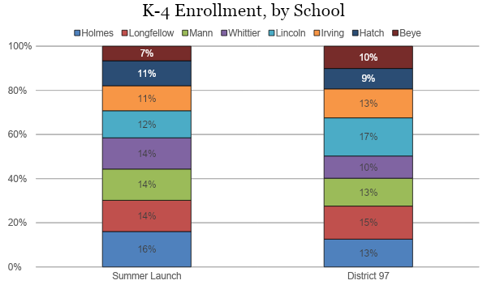

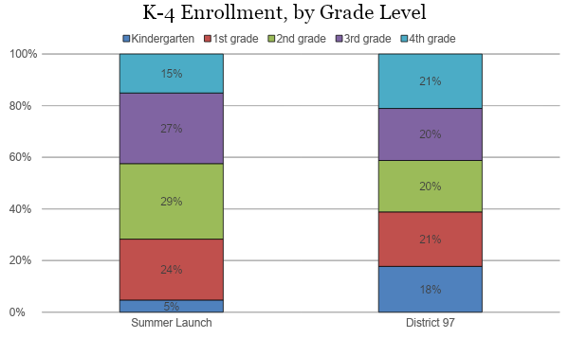

There were more male than female students in the K-4 Summer Launch program, 52% to 48%, while the district overall is closer to a 50/50 split.

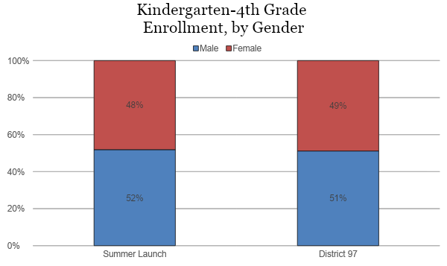

In terms of race/ethnicity, the most noticeable difference was that the percentage of black, hispanic, and mixed race students participating in the K-4 Summer Launch program was higher than the district-wide percentage by 10 percentage points, 8 percentage points, and 2 percentage points respectively. The percentage of white students in Summer Launch was 19 percentage points lower than the district percentage.

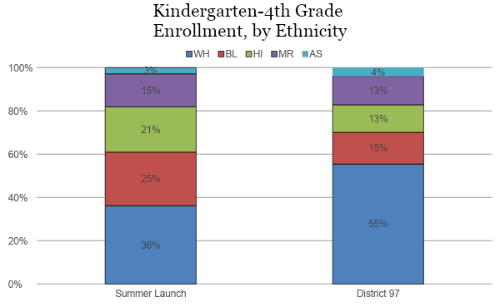

The proportion of students with Individualized Education Plans (IEPs) in the K-4 Summer Launch program was significantly higher, when compared to our district’s student enrollment, with 31% of our Summer Launch students having IEPs compared with 12% of our district-wide student population.
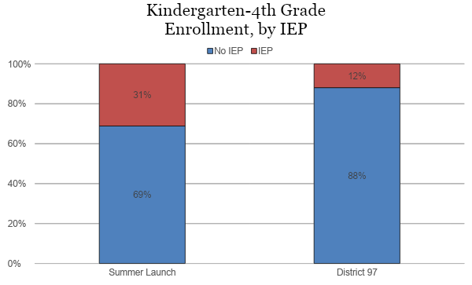

Lastly, 24% of students participating in Summer Launch received free or reduced-price lunch, which is 8 percentage points more in comparison to our district-wide population.

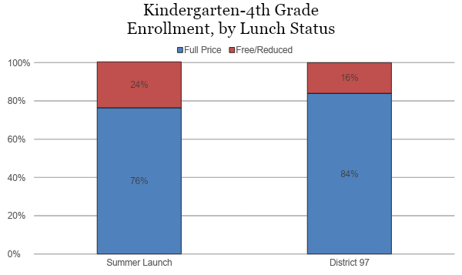

Student Assessment Data Analysis
As mentioned above, the student assessment data we collected for instructional purposes are also useful in determining the effectiveness of the program. Summer Launch teachers assessed students on the following:
- Reading Levels (Benchmark Assessment System)
- On-Demand Narrative Writing Assessment Scores (writing rubrics)
- Math Skill Growth
- Student survey

According to Benchmark Assessment System results, students in grades K-4 increased an average of one reading level during Summer Launch. Additionally, no students in grades K-4 decreased a reading level during the program. Seventy five percent of 4th grade students improved at least one level, while 25% stayed the same. Ninety percent of students in 3rd grade increased at least one level, while 10% stayed the same. Seventy three percent of 2nd grade students increased at least one level and 27% stayed the same. Seventy percent of 1st grade students increased at least one level and 30% stayed the same. Incoming kindergarten students entered the program below Level A and all increased at least one level.

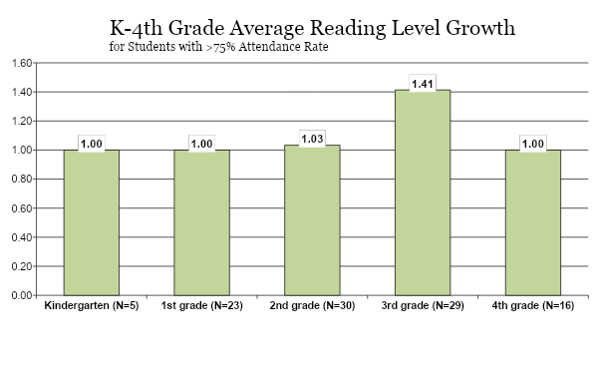
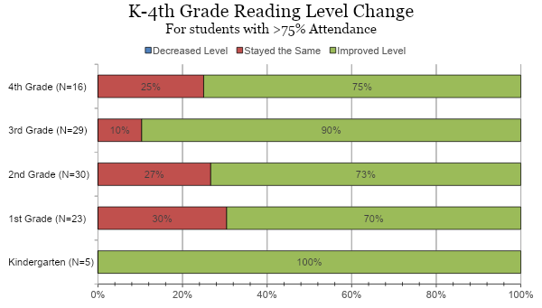

Pre and post assessments in the area of mathematics were tailored to student needs, based on incoming data. The assessments targeted number and operations, number writing, counting and cardinality, operations and algebraic thinking, numbers operation base ten, data and geometry, and measurement. Students in grades 2 and 3 increased over 6 points. There was also an increase of 3.9 points for 1st grade students, 1.4 points for kindergarten students, and 1.2 points for 4th grade students.
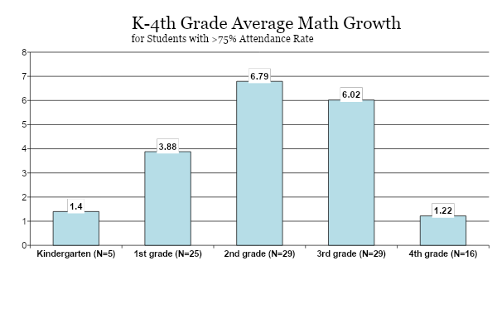
Student Survey Results
At the end of the program we surveyed the first through fourth grade students. Of the students responding, 81% K-4 Summer Launch students felt like they belonged, 78% of students had fun learning, 86% of students worked hard, and 90% of students believed their teacher treated them with respect. The students who were neutral or had negative responses were a small percentage of Summer Launch students.

Kindergarten - 4th Grade
Student Survey Results
Survey Questions | Strongly Agree/ Agree % | Neutral % | Disagree/ Strongly Disagree %
I feel I belong | 81% | 14% | 4%
I have fun learning | 78% | 10% | 10%
I work hard | 86% | 10% | 3%
My teacher treats me with respect | 90% | 5% | 3%

K-4 Summer Launch Successes and Future Considerations
Strengths:
- Recruited and hired highly skilled teachers.
- Strengthened curriculum for K-4 program by utilizing Language Literacy Intervention within the workshop model.
- Incorporated breakfast, snack, and recess into the schedule.
- Collaborated with E Team around Family and Student Engagement strategies.
- Implemented Kagan strategies throughout program.

Areas of Opportunity:
- Continue to further develop mathematics curriculum for grades K-4.
- Purchase math manipulatives for Summer Launch program.
- Consider hiring an administrative assistant and nurse.

5-8 Summer Launch:

5-8 Summer Launch Staffing
We hired one coordinator and four teachers for the 5-8 Summer Launch program. An open application was sent to all D97 teachers. We considered the following factors in our hiring process:
- application questions/responses
- grade currently teaching
- past experience with project-based learning
- principal recommendations and feedback

The following is a list of our selected staff for the 5-8 program:
- Coordinator: Arnetta Thompson, Lincoln

- Teachers:
  - Natalie Bauman, Beye
  - Nichelle Stigger, Brooks
  - Alicia Jenkins, Hatch
  - Renee Hannan, External Hire

- Social Worker:
  - Donna Glover, Whittier

5-8 Summer Launch Curriculum and Professional Learning
The Summer Launch program serves students who are receiving Tier 3 intervention support in their schools during the school year. The Summer Launch curriculum for grades 5-8 engaged students in the HEPH ED AUTOROBO STEAM curriculum which is a student-centered, project based, multi-disciplinary STEAM education platform specifically designed to help learners get excited about STEM, problem solving and the future of work. The AUTOROBO STEAM curriculum afforded students the opportunity to:
- Engage in lessons that will incorporate English language arts and mathematics activities
- Solve problems with the aid of exciting STEM tools and activities
- Participate in hands-on activities and topics that included robotics and pre-engineering experiences.

Prior to the Summer Launch program, the 5-8 coordinator and teachers participated in the following professional learning opportunities:
- AUTOROBO STEAM - 2 days (HEPH ED)
- Family & Student Engagement - 3 hours (E Team)

End-of-Program Reports for Families
An End-of Program Student Report was sent home with students which provided families with information on:
- Targeted skills for student learning in reading, mathematics, and engineering (pre and post assessments)
  - Main Idea and Details
  - Problem Solving and Operations
  - Claims & Evidence
- Behaviors that support student learning

5-8 Summer Launch Program Evaluation:

5-8 Student Enrollment and Attendance
According to our student demographic data for the 5-8 Summer Launch program, 45 students began the program and 37 students completed the program with a 75% attendance rate. Eight students either dropped or withdrew from the program, and we saw an 82% completion rate.

The largest percentage of students who participated in the program came from Brooks followed by Julian. The 5-8 Summer Launch program also had a larger proportion of 5th, 6th and 8th grade students participate, in comparison to district enrollment.

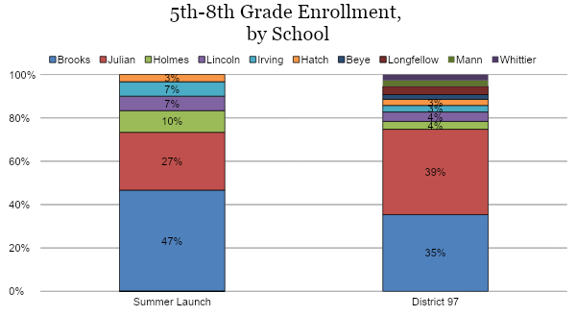

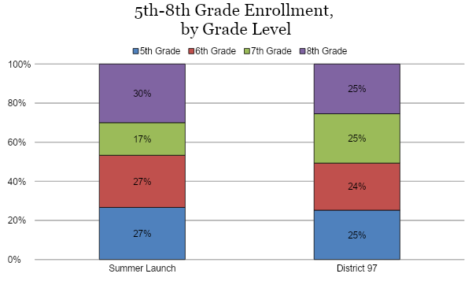

The proportion of male and female students in the 5-8 Summer Launch program was different than the district-wide proportion, with 60% of Summer Launch students identified as male and 40% of Summer Launch students identified as female.

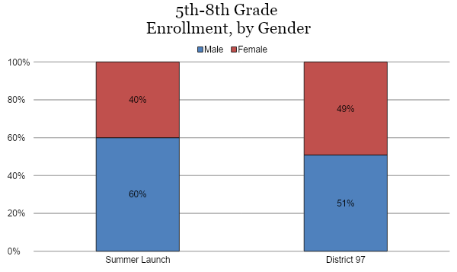

In terms of race/ethnicity, the most noticeable difference was that the percentage of black students participating in the 5-8 Summer Launch program was significantly higher than the district-wide percentage by 47 percentage points, and the percentage of white students in Summer Launch was significantly lower by 42 percentage points.

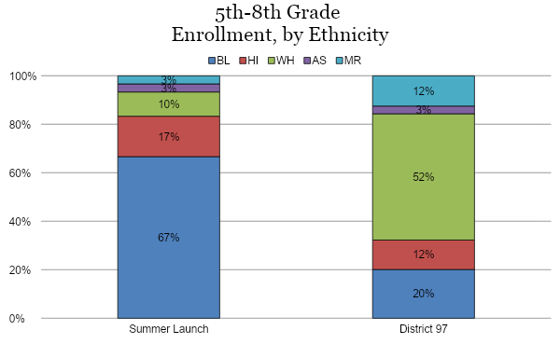

The proportion of students with Individualized Education Plans (IEPs) in the 5-8 Summer Launch program was higher, when compared with our district’s student enrollment, with 27% of our Summer Launch students having IEPs compared with 16% of our district-wide student population.

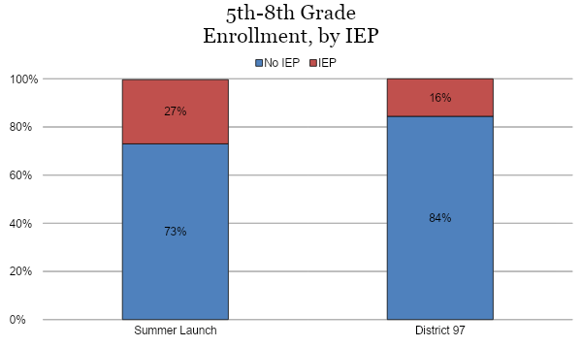

Lastly, 74% of students participating in Summer Launch receive free or reduced-price lunch, which is significantly higher than our district-wide percentage which is 19%.

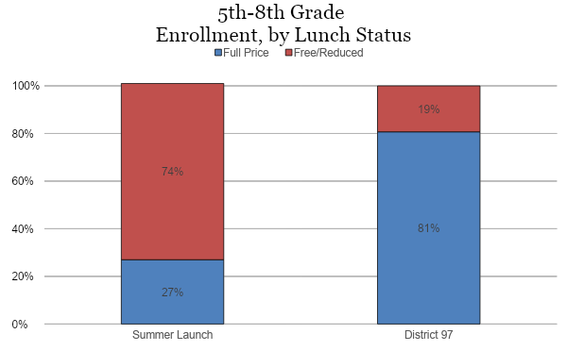

Student Assessment Data Analysis
As mentioned above, the student assessment data we collected for instructional purposes are also useful in determining the effectiveness of the program. Summer Launch teachers assessed students on the following:
- Targeted skills for student learning in reading, mathematics, and engineering (pre and post assessments)
  - Main Idea and Details
  - Problem Solving and Operations
  - Claims & Evidence
- Student survey

According to the pre and post assessments in the area of reading, overall students in grades 5-8 demonstrated growth during Summer Launch. We are excited to highlight 5th grade students increased an average of 34 points, 6th grade students increased an average of 7.4 points, 7th grade students increased an average of 4 points, and 8th grade students increased an average of 1.3 points.

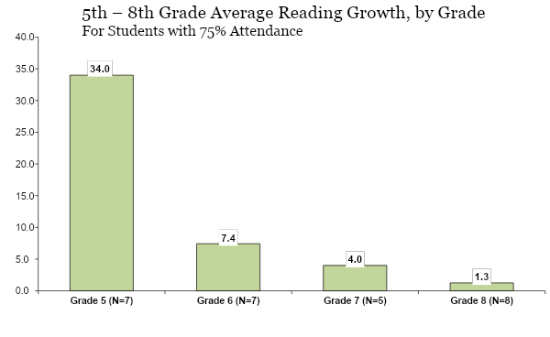
According to the pre and post assessments in the area of mathematics, overall students in grades 5-8 demonstrated growth during Summer Launch. Fifth grade students increased an average of 23.3 points, 6th grade students increased an average of 3.7 points, 7th grade students increased an average of 12 points, and 8th grade students increased an average of 31.3 points.
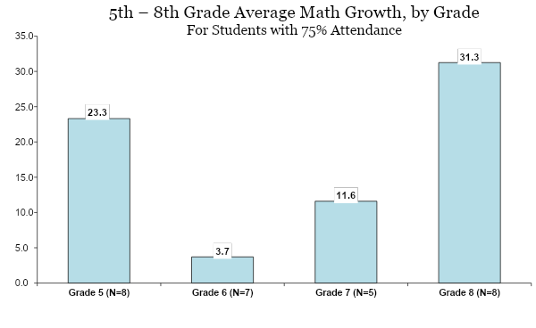

Student Survey Results
At the end of the program we surveyed the fifth through eighth grade students. Of the students responding, 78% 5-8 Summer Launch students felt like they belonged, 66% students had fun learning, 75% of students worked hard, and 86% of students believed their teacher treated them with respect. The students who were neutral or had negative responses were a small percentage of Summer Launch students.

5th - 8th Grade
Student Survey Results
Survey Questions | Strongly Agree % | Agree % | Neutral % | Disagree% | Strongly Disagree %
I feel I belong | 49% | 29% | 20% | 0% | 3%
I have fun learning | 46% | 26% | 17% | 3% | 9%
I work hard | 46% | 29% | 23% | 3% | 0%
My teacher treats me with respect | 77% | 9% | 14% | 0% | 0%

5-8 Summer Launch Successes and Future Considerations
Strengths:
- Revamped curriculum from the previous school year provided more hands-on and engaging learning opportunities for students.
- Created smaller class sizes that allowed teachers to build relationships and focus on the needs and skills of individual students.
- Provided professional learning during the school year to prepare teachers for the program.
- Ensured the necessary materials were provided and technology was readily available.

Areas of Opportunity:
- Provide additional time during training for teachers to discuss and daily activities and lesson pacing.
- Allow less time for scheduled breaks to maintain student engagement.

Newcomer EL Summer Program:
This year, we launched a new summer program for English Learners (EL). The Newcomer English Learner Summer Program was designed to support students who are new to the United States and acquiring the English language.

Coordinator and teacher recruitment began in early February with an application sent to all D97 teachers. The following is a list of our selected staff for the Newcomer EL Summer program:
- Coordinator: Parisa Asgharzadeh, Holmes

- Teachers:
  - Jennifer Jaros, Mann
  - Elizabeth Chase Vivas, Hatch
  - Deanna Otten, Irving

1-8 Newcomer EL Summer Program Curriculum and Professional Learning
This program provided an opportunity for students developing English Language skills to receive direct instruction with a focus on oracy in a small group environment. The teaching and learning department purchased the REACH curriculum which proved to be an excellent curriculum for teaching EL students. Students received instruction Monday through Thursday from 8:00 am to 12:00 pm and attended a field trip to enhance their learning every Friday.

Prior to the Newcomer EL Summer program, the coordinator and teachers participated in the following professional learning opportunities:
- REACH Curriculum Overview & Planning - 1 day (Coordinator)
- Kagan Training - 2 days (Kagan)
- Family & Students Engagement - 3 hours (E Team)

End-of-Program Reports for Families
An End-of Program Student Report was sent home with students which provided families with information on:
- Academic progress in vocabulary development (pre and post assessments)
- Oracy development
- Behaviors that support student learning

1-8 Newcomer EL Summer Program Evaluation:
According to our student demographic data for the 1-8 Newcomer EL Summer program, 13 students were enrolled in the program.

The largest percentage of students who participated in the program came from Holmes followed by Lincoln, Longfellow and Hatch. The 5-8 Summer Launch program also had a larger proportion of 1st, 4th, and 5th grade students participate in comparison to district enrollment. Additionally, there was one incoming 9th grade student who attended the program.

1-8 Newcomer EL Summer Program Student Enrollment and Attendance
 | K | 1st  Grade | 2nd Grade | 3rd  Grade | 4th  Grade | 5th  Grade | 6th  Grade | 7th  Grade | 8th  Grade
Enrollment - Newcomer EL | 1 | 5 | 1 | 0 | 3 | 2 | 1 | 0 | 0

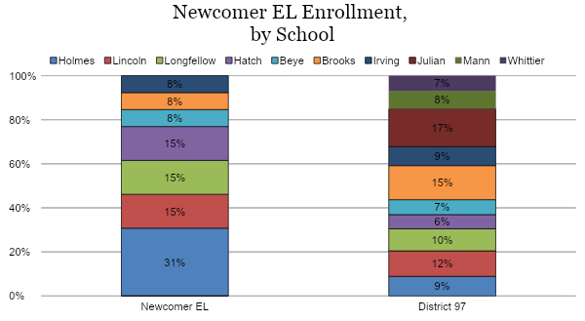
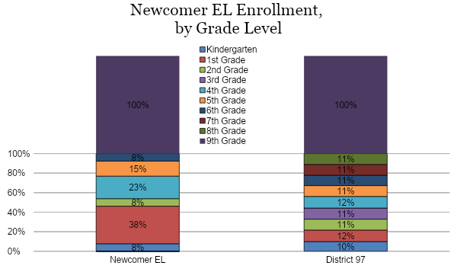
The proportion of male and female students in the 1-8 Newcomer EL Summer program was different than the district-wide proportion, with 54% of Newcomer EL students identified as male and 46% of Newcomer EL students identified as female.

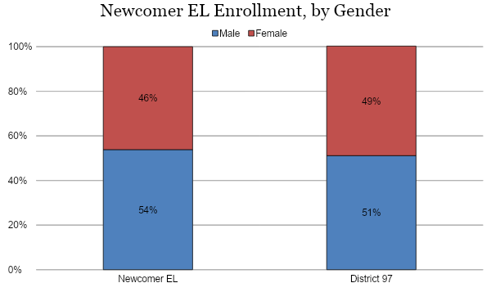

The proportion of students with Individualized Education Plans (IEPs) in the 1-8 Newcomer EL Summer program was lower, when compared with our district’s student enrollment, with 8% of our Newcomer EL students having IEPs compared with 14% of our district-wide student population.

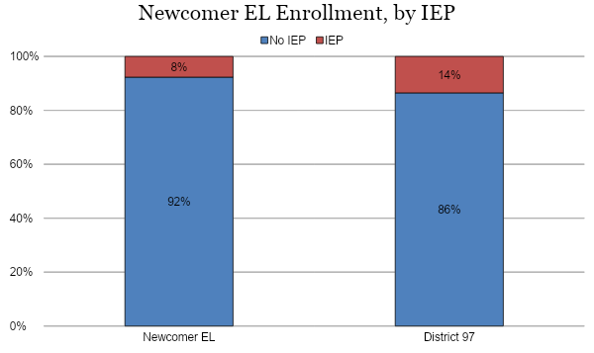

Lastly, 46% of students participating in the Newcomer EL Summer program receive free or reduced-price lunch, which is significantly higher than our district-wide percentage which is 17%.

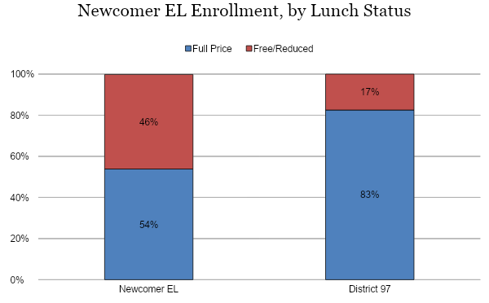

Student Assessment Data Analysis
To evaluate the success of the 1st-8th grade Newcomer EL Summer program, we administered pre and post assessments in the area of vocabulary development. Students in grades 4, 5 and 6 demonstrated an increase of 11, 15, and 10 points respectively. While kindergarten students increased 4 points, 1st grade students increased 9 points and one 2nd grade student did not demonstrate growth.

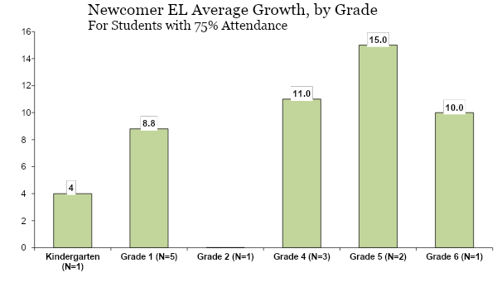

Student Survey Results
At the end of the program we surveyed the first through eighth grade students. Of the students responding, 83% 1-8 Newcomer EL students felt like they belonged, 89% of students had fun learning, 89% of students worked hard, and 100% of students believed their teacher treated them with respect. The students who were neutral or had negative responses were a small percentage of Summer Launch students.

Survey Questions | Strongly Agree % | Agree % | Neutral % | Disagree% | Strongly Disagree %
I feel I belong | 50% | 33% | 17% | 0% | 0%
I have fun learning | 61% | 28% | 6% | 6% | 0%
I work hard | 78% | 11% | 11% | 0% | 0%
My teacher treats me with respect | 89% | 11% | 0% | 0% | 0%

1-8 EL Newcomer Summer Program Successes and Future Considerations
Strengths:
- Implemented the REACH Curriculum to actively engage and immerse students in a connected, expanding, and dynamic language environment.
- Incorporated breakfast and snack into the schedule.
- Provided an opportunity for teachers to build relationships with EL students.

Areas of Opportunity:
- Provide space for all EL students to be in the same location.
- Track student growth in the areas of writing and oracy.

Middle School Summer Math Enrichment:

The Middle School Summer Math Enrichment program offers an opportunity for sixth through eighth grade students wishing to review math content and seek to advance a math level. The focus of this math enrichment program is to provide a structure that will allow students to deepen their understanding of math skills and previously learned concepts, as well as giving students a preview of content for the upcoming school year.

The Middle School Summer Math Enrichment program was located at Julian Middle School this summer, June 17 through July 3, 2019. Students attended class Monday - Friday and were able to choose from sessions that met from 8:00 AM - 10:00 AM or 10:00 AM - 12:00 PM.

Coordinator and teacher recruitment began in early February with an application sent to all D97 teachers. The following list of our selected staff for the Summer Math Enrichment program:

- Coordinator: Anna Kinnaman, Brooks

- Teachers:
  - Lawrence Harvey, Julian
  - Nina Diehl, Irving
  - Caroline Delia, Brooks
  - Danielle McDaniels, Whittier
  - Jeffry Weber, Longfellow
  - Mark Hausfeld, Brooks
  - Darren Kraft, Julian

Recruitment for the Middle School Summer Math Enrichment program began in early March with communication being sent to families of 5th, 6th, and 7th graders via the Digital Backpack. Flyers were also shared with families during parent-teacher conferences in February. The course fee was $180 and scholarships were provided for students receiving free or reduced-price lunch.

Summer Math Enrichment Enrollment
According to our student enrollment data for the Summer Math Enrichment program, 78 students were enrolled in review courses. Additionally, 118 students were enrolled in bridge courses.
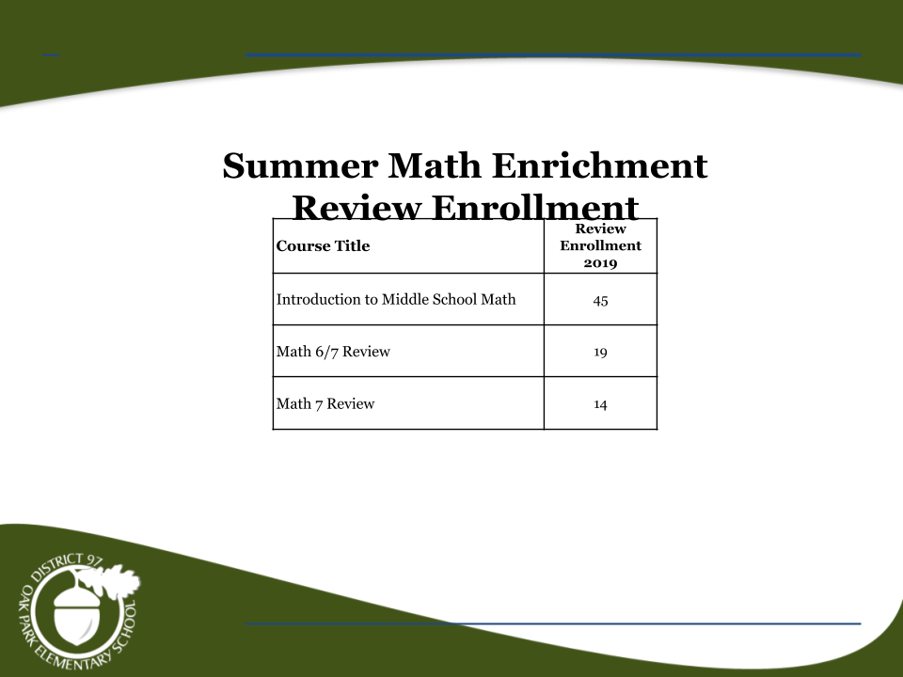

Bridge Course Student Assessment Data Analysis
The majority of students enrolled in Middle School Summer Math Enrichment were seeking to advance math levels and the remaining students are enrolled as a review opportunity. In order to advance to the next math level, students are required to score an 80% or better on the end of course exam. Given the course length, this a very accelerated program that requires a strong commitment from students and families.

We offered four bridge courses to middle school students this summer, two of the four courses had a pass rate of over 50%. The pass rate for the Math 6/7 Blended Learning course was 76% and the pass rate for Advanced Algebra 7 course was 55%. The pass rate for the Math 7/8 course and Algebra 7 was 43% and 11% respectively.

Given students’ busy summer schedules, District 97 offered an Independent Study option for those students who cannot attend Summer Math Enrichment. Students are provided with the course objectives and access to online materials. Out of the 18 students who enrolled in Independent Study, 10 students attended an exam session. Of these 10 students, 4 students passed the end-of-course exam. Eight students did not attend an exam session at all.

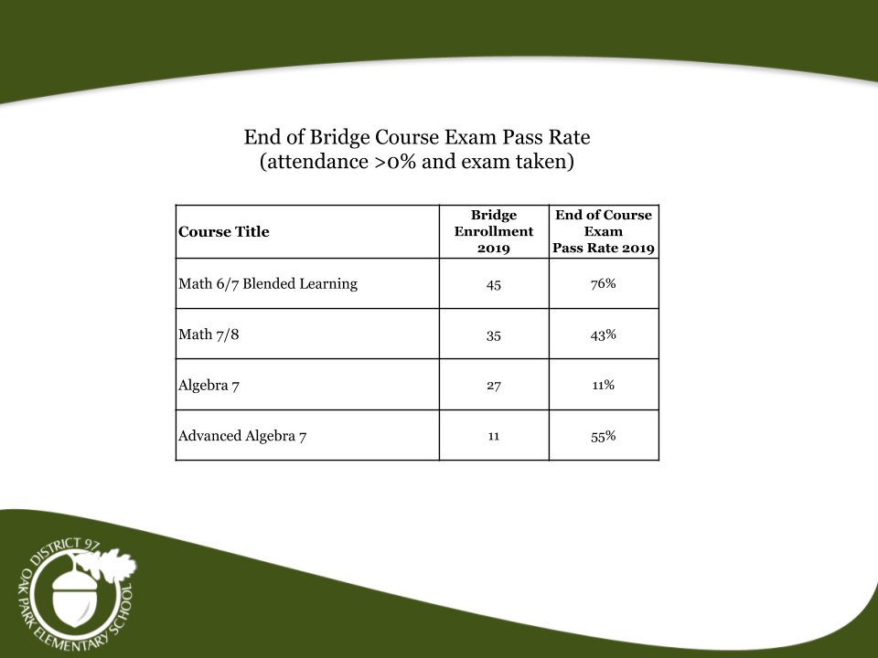

Math 6/7 Blended Learning Pilot Analysis
This summer, we piloted a bridge blended learning course for incoming 6th grade students. Students who were interested in accelerating into Math 7/8 for the 2019-2020 school year participated in the Math 6/7 Blended Learning bridge course during the summer. This opportunity was designed to increase access to advanced course taking for as many students as possible. In addition to receiving recommendations from elementary principals, the E Team assisted the teaching and learning department with reaching out to families to recruit students for this course. We would like to highlight that 76% of the students who participated in this summer course passed the end of course exam and were promoted to Math 7/8.

Our analysis of the Math 6/7 Blended Learning course enrollment and pass rate as it relates to race/ethnicity includes the following: White students demonstrated a 68% pass rate, black students received a pass rate of 83%, hispanic students demonstrated a pass rate of 80%, asian students received a 100% pass rate, and multiracial students demonstrated a pass rate of 75%.

Additionally, 100% of students who receive free/reduced price lunch passed the end of course exam and 72% of students who receive full price lunch passed the end of course exam. In terms of gender, 84% of female students and 71% of male passed the end of course exam.

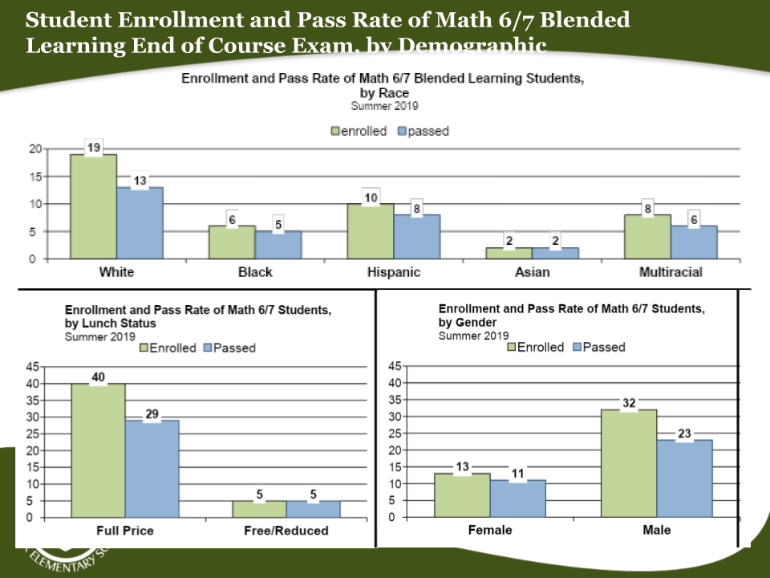

Twelve families responded to the family survey regarding the pilot. Listed below is a summary of their responses:
- All 12 families believed it was beneficial to provide students the opportunity to attend a face-to-face class on the first day of the program.
- Seven out of twelve families indicated a rating of 3 or above on a scale of 1-5 when asked if the family preferred their child taking this course online as opposed to a face-to-face class each day.
- In terms of the platform that was utilized for the class, 90% of families indicated Zoom and Khan Academy were easy for their child to navigate.
- The responses were split 50% yes and 50% no when asked if participating in the course via Zoom each day provided an amount of adequate support.

Forty students participated in the student survey about their experience. Listed below is a summary of their responses:
- Ninety percent of all students believed it was beneficial to attend a face-to-face class on the first day of the program.
- Eighty seven percent of students preferred taking this class online as opposed to attending face-to-face classes each day. Additional feedback provided by students who answered no referenced frustration in not being able to ask questions if they did not participate in the live session. Those who answered yes indicated they liked the format because of the ability to work more independently and outside of the class session window. Many students who answered yes indicated enjoying being in their own space and not having to come to school early in the morning.
- Ninety two percent of students indicated that Zoom was easy to navigate and 92% of students believed Khan Academy was easy to navigate.

Summer Music Camp Program:

District 97’s Summer Music Camp provides students in grades 4-8 with additional music experience that compliments what they are learning in our general music and instrumental music programs. The program was held at Julian Middle School from July 29 through August 2. Students attended the program one week from 8:15 am to 3:15 pm. Classes were one hour and forty minutes and students had the option of participating in one, two, or three classes. Student fees were $75 for one session, $150 for two sessions, or $225 for three sessions. Scholarships were available for District 97 students who receive free or reduced lunch.

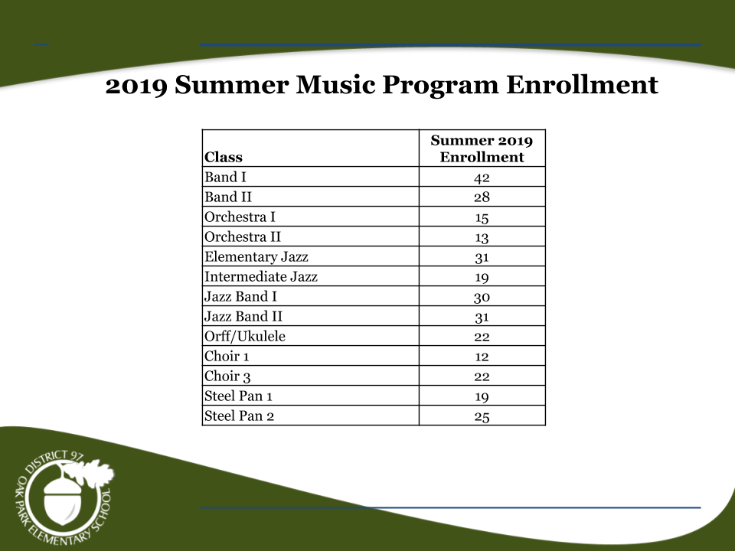

Extended School Year Program 2019:
The program overview and analysis of the 2019 Extended School Year Program may be accessed here.

Community Partnerships:

This summer, we partnered with the following four community organizations:

Equity Team Inc. (E Team)
The E Team provided family and student engagement support for the K-8 Summer Launch, Newcomer EL Summer, and Middle School Summer Math Enrichment programs. Before the start of summer programming, the E Team provided direct outreach to families enrolled in summer school and implemented family and student engagement training for teachers. During the program, the E Team hosted a welcome event to connect with enrolled families, delivered weekly training for teachers on the topics of family engagement and restorative justice practices, and connected families to community resources and services where needed. You may access a summary and analysis of their services here.

Beyond Hunger (Formerly Oak Park River Forest Food Pantry)
The teaching and learning and food service departments collaborated with Beyond Hunger and Oak Park & River Forest High School to pilot a summer food pilot. This pilot provided a healthy breakfast and snack to Summer Launch, ESY, and Newcomer EL students. You may access a summary and analysis of this pilot here.

Park District of Oak Park
The Park District of Oak Park provided extended camp services for summer school students in grades K-8. Scholarships were available to students who qualify. The following programs were offered to D97 students:
- Day Camp - M-F 12:00 pm - 3:00 pm - Participants spent their afternoons in a general day camp setting with theme based activities (games, crafts, scavenger hunts, swimming) $358
- Day Camp + Extended - M-F 12:00 pm - 6:00 pm - Participants engaged in small and large group activities, outdoor activities, and the Park District of Oak Park will provide a snack. $706

Oak Park Public Library
The Oak Park Public Library supported D97 students through their Summer Reading Program “A Universe of Stories.” The library purchased books for classroom use during the Summer Launch program to supplement our classroom libraries. Incentives were also provided to encourage students to read 20-minutes daily. Additionally, the Oak Park Public Library scheduled Summer Launch story time for younger students.

PART TWO: 2020 Summer Program Recommendations

The information in this section of the report is divided into the following four sections:

- D97 2020 Summer Program Schedule
- Summer Launch Student Selection Criteria
- 2020 Summer Program Recommendations
- Proposed Timeline
- Proposed Budget

The data provided below captures the average RIT score growth from spring to fall 2019 of Tier 3 students in grades 3-8 who attended our Summer Launch program compared to District 97 Tier 3 students who did not attend Summer Launch. Based on this overall positive data, we plan to refine and improve on the program from last summer, and will be keeping the major program components in place. In the area of reading, on average students who attended Summer Launch outperformed District 97 Tier 3 students with an overall RIT score growth of 12.19 compared to District 97’s increase of 7.15. Students who attended Summer Launch in 3rd, 4th and 5th grade increased over 10 points compared to District 97 Tier 3 students.

However, 7th and 8th grade students who attended Summer Launch showed an increase of 13.5 and 19 points compared to District 97’s increase of 8.43 and 15 points respectively.
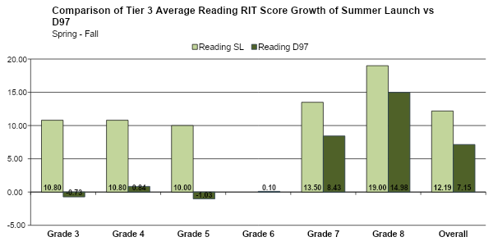

In the area of mathematics, on average students who attended Summer Launch outperformed District 97 Tier 3 students with an overall RIT score growth of 6.07 compared to District 97’s increase of 3.47. Students who attended Summer Launch in 3rd, 4th, 6th, and 7th grade increased 12.3, 2.5, 2.5, and 9.2 points respectively compared to District 97 Tier 3 students. However, 5th and 8th grade students who attended Summer Launch demonstrated a decrease of 2.6 and an increase of 3.5 points compared to District 97’s decrease of 2.5 and an increase of 7.3 points respectively.

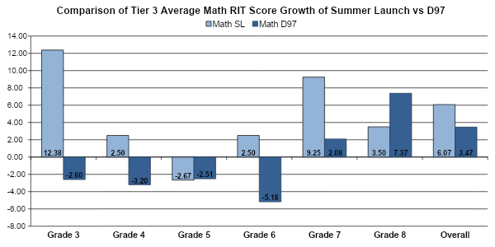

D97 Summer 2020 Summer Program Schedule:

No School - July 3
- K-4 Summer Launch: June 15 - July 10 at Holmes
  - Monday through Friday, 8:00 am - 12:00 pm

- 5-8 Summer Launch: June 15 - July 10 at Brooks
  - Monday through Friday, 8:00 am - 12:00 pm

- Extended School Year: June 15 - July 10 at (EC @ Whittier, K-4 @ Holmes, and 5-7 @ Brooks)
  - Monday through Friday, 8:00 am - 12:00 pm

- 6-8 Middle School Summer Math Enrichment: June 15 - July 2 at Brooks
  - Monday through Friday, 8:00 am - 10:00 am OR 10:00 am - 12:00 pm

- 1-8 Newcomer English Learner Summer Program: June 15 - July 10 at Whittier
  - Monday through Friday, 8:00 am - 12:00 pm (Field Trip - every Friday)

- 4-8 Summer Music Camp: July 20 - July 24 at Brooks
  - Monday through Friday, 8:15 am - 3:15 pm

Summer Launch Student Selection Criteria:

Summer Launch
All students invited to Summer Launch must be identified as Tier 3 during the school year based on at least one of the following benchmark assessments:
- Northwest Evaluation Association Measures of Academic Progress
- AimswebPLUS
- Benchmark Assessment System

English Learners
Once again this year, English Learners (EL) will be joining in the Summer Launch program. Students with ACCESS scores of 3.0 and below will be invited to the Summer Launch program. Additionally, the Newcomer English Learner Summer Program will be implemented again this year to support students who are new to the United States and acquiring the English language.

Students with Disabilities
Students with an Individual Education Plan (IEP) will continue to be included in the Summer Launch program if they qualify for tier 3 services and are not invited to attend Extended School Year per their IEP.

2020 Summer Program Recommendations:

This section will highlight the teaching and learning department’s summer program recommendations for 2020 which includes staffing, family communication, curriculum development, professional learning, and summer community partnerships.

Summer Program Staffing
In an effort to recruit and hire highly skilled staff, applications will be sent to District 97 staff in January and positions will be secured by the end of February. The following positions will be available for D97 staff:

Coordinator Positions | Teacher/Social Worker Positions
(1) K-4 Summer Launch | (18) K-8 Summer Launch Teachers
(1) 5-8 Summer Launch | (8) Middle School Summer Math Enrichment
(1) Middle School Summer Math Enrichment | (3) Newcomer English Learner
(1) Newcomer English Learner | (6) Summer Music Camp
(1) Summer Music Camp | (1) Summer Launch Nurse
 | (1) Summer Launch Administrative Assistant
 | (1) K-8 Summer Launch Social Worker

Summer Launch Program Communication
Summer Launch invitation letters will be sent to families by January 15 pending Board of Education approval. We will determine if invitations will be re-sent to families in February and March. Summer Launch registration will close on May 15.

Curriculum Development and Professional Learning
K-4 Summer Launch
- Curriculum Development:
  - The Summer Launch program is designed to extend learning over the summer, while providing engaging and interactive experiences for students. Each day, students will engage in reading and writing workshop and mathematics.
  - Professional Learning - Professional learning opportunities will be provided to teachers in May and June.

5-8 Summer Launch
- Curriculum Development:
  - This summer, the teaching and learning department will continue to partner with HEPH ED Steam to develop the curriculum for the 5-8 Summer Launch program. The AUTOROBO STEAM program is aligned to the Illinois Learning Standards and the Next Generation Science Standards. AUTOROBO STEAM is an innovative approach to STEAM, designed for the disenfranchised learner and includes project based activities that assists students with their individual pathway.
  - Professional Learning - Professional learning opportunities will be provided to teachers in May and June.

Middle School Summer Math Enrichment
- Curriculum Development:
  - The teaching and learning department will continue to offer review and bridge courses for middle school students. The table below represents the Middle School Summer Math Enrichment courses that will provide students opportunities for review and acceleration.
  - Professional Learning - Professional learning opportunities will be provided to teachers during the month of May.

2020 Summer Review Courses
Introduction to Middle School Math | Current 5th grade students
Math 6/7 | Current 6th grade students
Math 7/8 | Current 7th grade students
2020 Summer Bridge Courses
Math 6/7 Blended Learning Course | Current 5th grade students  - Test into Math 7/8 for 6th grade year
Math 7/8 (Grade level course for 7th graders) | Current Math 6/7 students in 6th grade  - Test into Math 8/9 for 7th grade year
Math 8/9 (Grade level course for 8th graders) | Current Math 7/8 students in 7th grade  - Test into Geometry for 8th grade year

1-8 Newcomer English Learner Summer Program
- Curriculum Development:
  - The teaching and learning department will collaborate with EL teachers to select an appropriate resource to meet the needs of English Learner students. This resource is being funded through the Title III grant.
  - Students will receive instruction Monday - Thursday from 8:00 am -12:00 pm and attend a field trip to enhance their learning every Friday.
  - Professional Learning - Professional learning opportunities will be provided to teachers during the month of May and June.

Summer Community Partnerships
As in the past, the teaching and learning department will continue to partner with the Park District of Oak Park and the Oak Park Public Library. Additionally, we will continue our partnerships with the E Team for family and student engagement support and Beyond Hunger for the summer food program.

Summer Launch Proposed Timeline:

The teaching and learning department will implement the proposed timeline to prepare for our upcoming summer programs.

Tasks | Timeline
Develop summer program curriculum and professional learning | November - March
Send invitation letters/communication to K-8 Summer Launch | January 15
Send applications to D97 staff for summer positions | January 24
Select teachers for summer positions and send notifications to staff | February
Determine if invitations should be re-sent for K-8 Summer Launch | February - March
Close K-8 Summer Launch registration | May 15
Provide teacher training for Summer Launch | May - June

Summer Launch 2020 Proposed Budget:

- $117,574

Item | Allocation
(18) Teacher Stipends | $64,800
(2) Coordinator Stipends | $9,800
(1) Nurse | $3,800
(1) Social Worker | $3,600
(1) Administrative Assistant | $1,824
HEPH ED Steam  - Curriculum Development  - Professional Development  - Resources/Materials | $5,000 fee  $1,250 - $250/teacher (5 teachers)  $10,000 - $200/student (50 students)
E Team  - Family Outreach  - Family & Student Engagement Training | $10,000
Summer Food Program  - Cost of Non Free/Reduced Meals  - Site Managers | $2,500  $5,000

