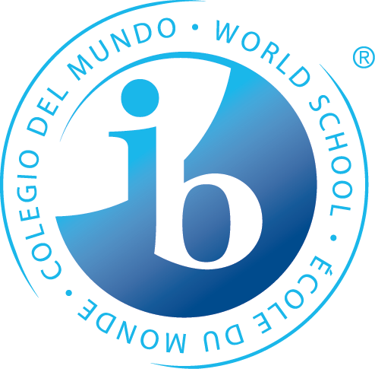
What is Happening in 6th Grade Trimester One?

Statements of Inquiry
The IB MYP emphasizes the power of “the big picture.” This means that teachers work to collaboratively develop a single, central statement for each unit that captures and reflects what’s so important about what students are learning – this is called the statement of inquiry. This statement represents the greater learning our students achieve through our content, leaving a permanent mark of greater knowing and understanding that will continue to develop throughout their lives. Below are the Statements of Inquiry 6th grade students will encounter during their first unit.
Math
Establishing patterns in the natural world can help justify and understand relationships.
Making connections between properties of polygons to support evidence-based explanations around functionality in science and nature.

Language & Literature
Relationships transform characters’ identities and their thoughts on life.

Individuals & Societies
As different cultures move in and out of a region, the identity of the region changes over time.

Science
Models are used to create evidence for the transfer of energy within systems.

PE/Health
The relationships and interactions we have with one another and our choices affect our successfulness.

Language Acquisition
French: Communication changes given one’s objective and the context in which one is speaking.
Spanish: Conveying a clear personal message builds a strong sense of identity and promotes a connection with others.

Design
Human development combined with innovation and evaluation, develops solutions to solve or satisfy human needs or wants.
*Some students may take this course Tri. 2 or 3
Arts
Visual Arts: Ideas and relationships can be expressed and communicated through choice of medium and composition prompting the motivation to create visual artifacts.
Performing Arts: Notation makes it possible to communicate and interpret musical ideas through reading, playing, and composing.
Speech, Drama & Debate: Expression to and from an audience influences successful communication to build identities and relationships.

Years from now, when the dates, formulas and facts have all but disappeared, what remains? Through the hard work, collaboration, and deep thinking of our teachers…our statements of inquiry will!

