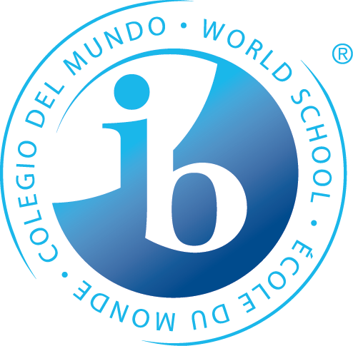

**What is happening in the first unit of 6th Grade?**

**Statements of Inquiry**

The IB MYP emphasizes the power of **“the big picture.”** This means that teachers work to collaboratively develop a single, central statement for each unit that captures and reflects what’s so important about what students are learning – this is called the **statement of inquiry**. This statement represents the greater learning our students achieve **through** our content, leaving a permanent mark of greater knowing and understanding that will continue to develop throughout their lives.

**Math**

Patterns in the natural world can justify and help us understand relationships.

**Language A**

Characters’ relationships and connections drive their perspectives, which, in turn, impacts their identities.

**Humanities**

As different cultures move in and out of a region, the identity of the region changes over time.

**Science**

Models are used to create evidence for the transfer of energy within systems.

**PE/Health**

The relationships and interactions we have with one another and our choices affect our successfulness.

**Language B**

**French:** Communication changes given one’s objective and the context in which one is speaking.

**Spanish:** Conveying a clear personal message builds a strong sense of identity and promotes a connection with others.

**Design**

Human development combined with innovation and evaluation, develops solutions to solve or satisfy human needs or wants.

*Some students may take this course Tri. 2 or 3

**Arts**

**Visual Arts:** Ideas and relationships can be expressed and communicated through choice of medium and composition prompting the motivation to create visual artifacts.

**Performing Arts:** Musical clef systems communicate a composer’s intent to provide you with information to correctly play and then later compose your own music.

**Speech, Drama & Debate:** Expression to and from an audience influences successful communication to build identities and relationships.

*Years from now, when the dates, formulas and facts have all but disappeared, what remains? Through the hard work, collaboration, and deep thinking of our teachers…****our statements of inquiry will!***