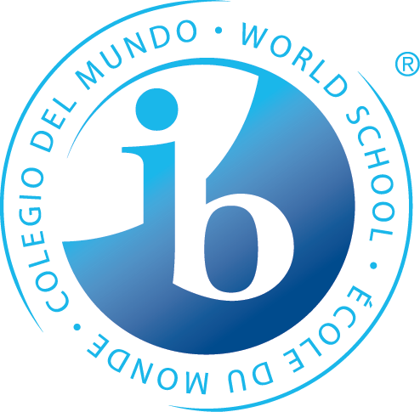
What is Happening in the 7th Grade Trimester One?

Statements of Inquiry
The IB MYP emphasizes the power of “the big picture.” This means that teachers work to collaboratively develop a single, central statement for each unit that captures and reflects what’s so important about what students are learning – this is called the statement of inquiry. This statement represents the greater learning our students achieve through our content, leaving a permanent mark of greater knowing and understanding that will continue to develop throughout their lives. Below are the Statements of Inquiry 7th grade students will encounter during their first unit.
Language & Literature and Individuals & Societies (interdisciplinary unit)
Our perspective causes us to seek a change in ourselves and/or the world.

Math
Math helps us do work that impacts our communities.
Logic impacts the form of communities.

Science
Interactions in a system illustrate invisible forces.

PE/Health
Positive changes are made when we make the choice to improve our movements and interpersonal skills.

Language Acquisition
French: A purpose of traveling is to gain a meaningful and tangible understanding of culture.
Spanish: Where we go and what we do in our communities help us to develop more cultural awareness and to build personal connections with a wider audience of people.

Design
Developing functioning systems, requires resources and collaboration, to create products as a way to improve our daily lives.
*Some students may take this course Tri. 2 or 3
Arts
Visual Arts: Aesthetic expression through composition is paramount in the formation of one’s identity. Personal and Cultural Expression can be represented in many ways, in order to communicate ideas and tell stories
Performing Arts: Notation makes it possible to communicate information to read, play, and compose.
Speech, Drama & Debate: Expression to and from an audience influences successful communication.

Years from now, when the dates, formulas and facts have all but disappeared, what remains? Through the hard work, collaboration, and deep thinking of our teachers…our statements of inquiry will!

