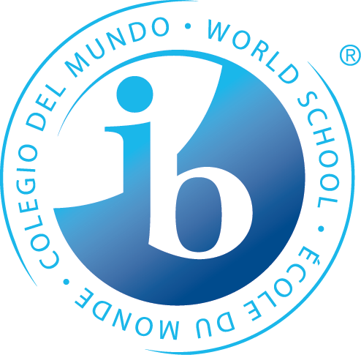

**What is Happening During the 2nd Trimester of 7th Grade?**

**Statements of Inquiry**

The IB MYP emphasizes the power of **“the big picture.”** This means that teachers work to collaboratively develop a single, central statement for each unit that captures and reflects what’s so important about what students are learning – this is called the **statement of inquiry**. This statement represents the greater learning our students achieve **through** our content, leaving a permanent mark of greater knowing and understanding that will continue to develop throughout their lives.

**Math**

*Using a model to represent relationships and patterns can improve decision making.*

**Language A**

*Culture shapes our identity and is communicated through our stories.*

**Humanities**

Different perspectives on how to govern leads to political conflict.

The meaning of citizenship requires an understanding of political, economic, and social systems.

**Science**

Energy is never lost or gained; rather it is transformed from one form to another.

Knowledge is open to revision in light of new evidence.

**Language B**

**French:**

It is important to let go of the English structure in order to create the correct structure when explaining relationships between people and their possessions.

People make different connections based on their interpretations of message and meaning gleaned from context.

**Spanish:**

Purpose dictates the patterns with which we communicate.

Meaningful communication allows others to understand the purpose of your trip.

*Years from now, when the dates, formulas and facts have all but disappeared, what remains? Through the hard work, collaboration, and deep thinking of our teachers…****our statements of inquiry will!***

**PE/Health**

Movement choices change based on the fitness exercises performed.

Students make choices to try and make positive change in their fitness levels.

**Arts**

**Visual Arts:**

Masterful artistry is achieved by expression of identity and exploration that goes beyond boundaries.

**Performing Arts:**

Rhythms communicate a composer’s intent to provide you with information to correctly play and then later compose your own music.

**Speech, Drama & Debate:**

The composition of identities and relationships changes with theatrical interpretation.

Interpretation of poetry takes form through actor as well as audience personal and cultural expression.

**Design**

Developing functioning systems, requires resources and collaboration, to create products as a way to improve our daily lives.

*Some students may take this course Tri. 1 or 3

*Years from now, when the dates, formulas and facts have all but disappeared, what remains? Through the hard work, collaboration, and deep thinking of our teachers…****our statements of inquiry will!***