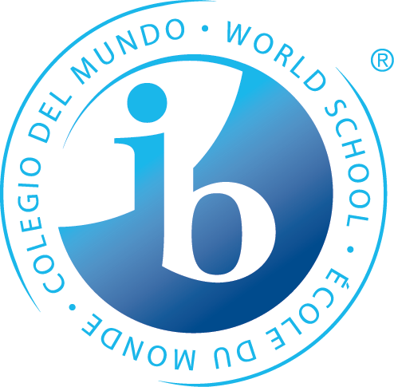
What is happening in the first unit of 7th Grade?

Statements of Inquiry
The IB MYP emphasizes the power of “the big picture.” This means that teachers work to collaboratively develop a single, central statement for each unit that captures and reflects what’s so important about what students are learning – this is called the statement of inquiry. This statement represents the greater learning our students achieve through our content, leaving a permanent mark of greater knowing and understanding that will continue to develop throughout their lives.
Language A
Our belief systems are communicated through our stories; therefore, sharing our stories with others challenges their perspectives.

Math
Lifestyle choices and relationships are influenced by patterns and models.
Equivalence and generalizations in relationships help lead to different processes for finding solutions.
Forming organized processes and models can simplify your life.

Humanities
A difference in perspective may lead to challenging authority in order to make change.

Science
Humans demonstrate ingenuity by balancing and manipulating forces to control the motion of an object.

Language B
French: A purpose of traveling is to gain a meaningful and tangible understanding of culture.
Spanish: Culture influences the purpose and function of family and celebrations.

PE/Health
Positive changes are made when we make the choice to improve our movements and interpersonal skills.

Arts
Visual Arts: Aesthetic expression through composition is paramount in the formation of one’s identity.
Performing Arts: Rhythms communicate a composer’s intent to provide you with information to correctly play and then later compose your own music.
Speech, Drama & Debate: Expression to and from an audience influences successful communication.

Design
Developing functioning systems, requires resources and collaboration, to create products as a way to improve our daily lives.
*Some students may take this course Tri. 2 or 3

Years from now, when the dates, formulas and facts have all but disappeared, what remains? Through the hard work, collaboration, and deep thinking of our teachers…our statements of inquiry will!

