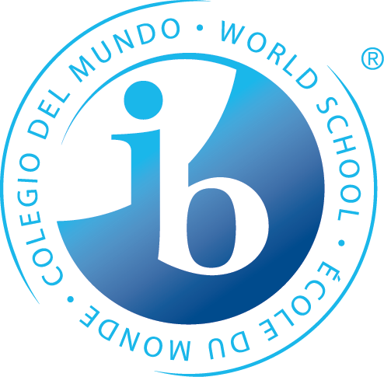
What is Happening in the 8th Grade Trimester One?

Statements of Inquiry
The IB MYP emphasizes the power of “the big picture.” This means that teachers work to collaboratively develop a single, central statement for each unit that captures and reflects what’s so important about what students are learning – this is called the statement of inquiry. This statement represents the greater learning our students achieve through our content, leaving a permanent mark of greater knowing and understanding that will continue to develop throughout their lives. Below are the Statements of Inquiry 8th grade students will encounter during their first unit.
Language & Literature
Through writing, authors purposefully explore controversial perspectives regarding government control with emphasis on human capability and civic responsibility.

Math
Logic is a method of reasoning and a system of principles used to build arguments and reach conclusions.
Form is the shape and underlying structure of an entity or piece of work, including its organization, essential nature and external appearance.
Forming organized processes and models can simplify your life.

Individuals & Societies
Social and personal development have been predicated upon a collision of ideologies that advocate self- interest and a simultaneous idea of collective notions of the good.

Science
Relationships are discovered through evidence and patterns in adaptations.

Language Acquisition
French: Your cultural conventions (including the language you speak) can give you power by opening up or denying opportunities.
Spanish: Communication with others promotes development of personal identity and social connections.

PE/Health
The choices of our movements affect our energy expenditure. Movement affects energy.

Design
A common method of communication is required for the function and invention of systems which can be utilized in a meaningful way.
*Some students may take this course Tri. 2 or 3
Arts
Visual Arts: The communication of one’s artistry is often based upon the expression of personal narrative and interpretation of medium. Personal and Cultural Expression can be represented in many ways, in order to communicate ideas and tell stories
Performing Arts: Notation makes it possible to communicate information to read, play, and compose.
Speech, Drama & Debate: Expression to and from an audience influences successful communication.

Years from now, when the dates, formulas and facts have all but disappeared, what remains? Through the hard work, collaboration, and deep thinking of our teachers…our statements of inquiry will!

