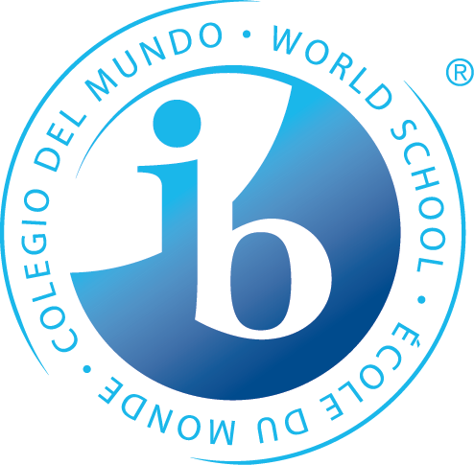
What is Happening During the 2nd Trimester of 8th Grade?

Statements of Inquiry
The IB MYP emphasizes the power of “the big picture.” This means that teachers work to collaboratively develop a single, central statement for each unit that captures and reflects what’s so important about what students are learning – this is called the statement of inquiry. This statement represents the greater learning our students achieve through our content, leaving a permanent mark of greater knowing and understanding that will continue to develop throughout their lives.

Language A

Examining a writer’s artistry through self-expression, structure and style allows readers to examine the formation of Identity by internal and external influences.

Math

Relationships can be represented through systems and patterns.

Simplification is a result of modeling relationships.

Every physical structure is formed from geometric transformations.

Humanities

Society finds it difficult to account for a shift in political and psychological forms of consciousness.

Personal and cultural destruction results when there is a fear of future change.

Science

Relationships are discovered through evidence and patterns in adaptations.

Years from now, when the dates, formulas and facts have all but disappeared, what remains? Through the hard work, collaboration, and deep thinking of our teachers…our statements of inquiry will!
PE/Health
The choices of frequency and variability influence progress development.

The choices we make about the way we interact with people directly affects our relationships.

Language B

French:
Messages that communicate historical, cultural and personal past are valuable in the present.

Messages that communicate historical, cultural and personal conventions of the past are valuable in the present.

Spanish:
The way we present ourselves in our daily lives sends different messages, depending on who we encounter and where.

Every country’s culture creates a bias that affects the message they send and receive through their personal choices.

Arts

Visual Arts:
Strategic change in our skill set will allow for a continued relevance in the presentation of our own unique style.

Performing Arts:
Rhythms communicate a composer’s intent to provide you with information to correctly play and then later compose your own music.

Speech, Drama & Debate:
How Shakespeare communicates a character’s role through dialogue and action is open to interpretation.

Rights, law and civic responsibility are given structure by, and are open to interpretation through, trials.

Design

A common method of communication is required for the function and invention of systems which can be utilized in a meaningful way.
*Some students may take this course Tri. 1 or 3

Years from now, when the dates, formulas and facts have all but disappeared, what remains? Through the hard work, collaboration, and deep thinking of our teachers…our statements of inquiry will!

