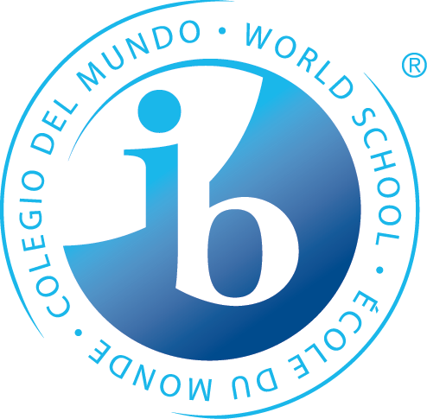

**What is happening in the first unit of 8th Grade?**

**Statements of Inquiry**

The IB MYP emphasizes the power of **“the big picture.”** This means that teachers work to collaboratively develop a single, central statement for each unit that captures and reflects what’s so important about what students are learning – this is called the **statement of inquiry**. This statement represents the greater learning our students achieve **through** our content, leaving a permanent mark of greater knowing and understanding that will continue to develop throughout their lives.

**Math**

Logic impacts the form of communities.

Forming organized processes and models can simplify your life.

**Language A**

The author’s creative use of literary elements, including characterization, point of view, and style, communicate his/her beliefs and values about individuals and relationships.

**Humanities**

Social and personal development have been predicated upon a collision of ideologies that advocate self- interest and a simultaneous idea of collective notions of the good.

**Science**

Investigating patterns and relationships to create models leads to innovations in engineering.

**PE/Health**

The choices of our movements affect our energy expenditure. Movement affects energy.

**Language B**

**French:** Understanding the audience, context, and vocabulary, enables effective communication allowing you to get what you want/need.

**Spanish:** Communication with others promotes development of personal identity and social connections.

**Arts**

**Visual Arts:** The communication of one’s artistry is often based upon the expression of personal narrative and interpretation of medium.

**Performing Arts:** Rhythms communicate a composer’s intent to provide you with information to correctly play and then later compose your own music.

**Speech, Drama & Debate:** Expression to and from an audience influences successful communication.

**Design**

A common method of communication is required for the function and invention of systems which can be utilized in a meaningful way.

*Some students may take this course Tri. 2 or 3

*Years from now, when the dates, formulas and facts have all but disappeared, what remains? Through the hard work, collaboration, and deep thinking of our teachers…****our statements of inquiry will!***