**Biographies due Wednesday, November 20**

We are all working hard and asking questions about our Biography papers. On Wednesday, I modeled how to take the facts that are written down and make them into sentences. We also talked about how to take one fact and combine it to another fact to make a more detailed fact. The class and I talked about how it is important to put the facts into their own words so that it sounds like they are telling the story about the person they read about. Rough drafts will be due the week of Nov. 11.

Upcoming Dates:

**Picture Retakes** – Wednesday, November 13

**Turkey Trot** – Thursday, November 21 – 3:30, Whittier Field (need permission slip-going home soon)

**Harvest Dance** – Friday, November 22, 6:30-8:00

**Thanksgiving Break** – Wed., -Fri. November 27-29

**PTO Meeting** – Tuesday, December 3, 7:00

**Report cards go home** – Friday, December 6

**Halloween Party**

Many thanks to the donation of treats, drinks and paper goods for the party. Everyone did a great job helping with passing out the food to cleaning up. We enjoyed just sitting back and being together. The costumes were amazing! They were super troopers what with the weather and all!!

**Curriculum**

***ELA (Reading / Writing)*** – In Reading Workshop, we are loving the Mystery unit! Some students can’t finish one fast enough. I have been very impressed at how students are really choosing books that challenge them. I am enjoying my conversations with each of them. They talk about what makes a mystery a mystery. They examine who would be likely suspects and what are the clues/evidence that support their thinking. The students make predictions about what they think will happen next. They have been fully engaged!

In Writing Workshop, we had a writing celebration last week with all the 3rd grade classes. We shared our small moment writing in small groups. It was great to see how the students are improving and writing more descriptively—like storytellers! Our next writing unit will be on Persuasive writing where they will choose an issue that they feel strongly about and write an essay to change a reader’s mind about that issue.

***Math*** – We are finishing up the part of this module on telling time and calculating elapsed time and are moving into addition and subtraction of 2- and 3-digit numbers with regrouping and borrowing through the study of measurement of solids and liquids. We will be working on addition/ subtraction without using the standard algorithm, but we will begin working with that soon. If students learn how to work with the numbers and think about them on the number line or on a hundreds chart, they become flexible thinkers about numbers and they will do mental addition and subtraction more easily. It can be frustrating, but the results can be surprising.

***Science-*** The class has had a few classes studying water and its elements. We have talked about surface tension and have even learned that there are insects that live on the top of the water and only can do that through surface tension. Be sure to ask your child what they have learned.

**Thanks for the Fun Run Support**

Because of your support of the Fun Run, our class received $25! With that money I will buy some wallballs, another Four-Square ball and headphones for the class. Thanks for your generosity in supporting Whittier School and our class.

**Socktober!** 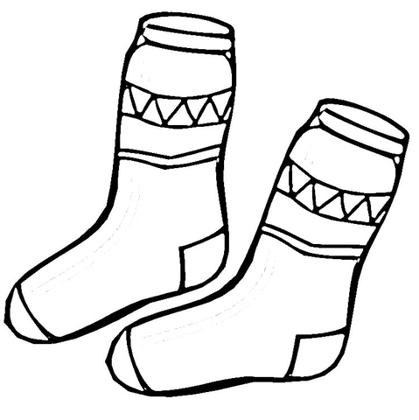

Our Student Council’s Socktober Sock Drive was quite a success. They collected 204 pairs of socks!! These socks have been donated to Housing Forward, a local homeless shelter, where they will be distributed. Many thanks for the support from our Whittier families!!

T.E.A.M. Report

Mrs. Hoehne’s Newsletter nhoehne@op97.org November 8, 2019