**Halloween Party**

Many thanks to the donation of treats, drinks and paper goods for the party. Everyone did a great job helping with passing out the food to cleaning up. We enjoyed just sitting back and being together. The costumes were amazing! I will send a class picture soon.

**Biographies due Friday**

It is so exciting to be at the end of our Biography project. I enjoyed seeing all of the rough drafts this week. I did put a little post it on the draft to let you know what I thought and any suggestions I had to help complete the paper. Let me know if there are any last-minute issues. We will talk about the presentation early next week and encourage everyone to practice sharing facts with family members at home.

**Curriculum**

***ELA (Reading / Writing)*** – In Reading Workshop, we have begun a unit on non-fiction reading. We are leaning strategies to help us read more deeply where we consider how the information is organized, we are learning to identify the main idea and supporting details, and we continue to work on figuring out the meaning of challenging words instead of skipping over them. We are reading a mix of fiction and non-fiction, but our emphasis is on non-fiction so we can practice the strategies that are taught in our mini-lessons.

In Writing Workshop, we had a writing celebration this week with all the 3rd grade classes. We shared our small moment writing in small groups. It was great to see how the students are improving and writing more descriptively—like storytellers! Our next writing unit will be on non-fiction writing where they will choose a topic that they are an expert at!

***Math*** – We are finishing up the part of this module on measurement and moving into addition and subtraction of 2- and 3-digit numbers with regrouping and borrowing. We are currently working on addition subtraction without using the standard algorithm, but we will begin working with that soon. If students learn how to work with the numbers and think about them on the number line or on a hundreds chart, they become flexible thinkers about numbers and they will do mental addition and subtraction more easily. It can be frustrating, but the results can be surprising.

***Soc. St./Science –*** We have started our Science unit, Motion and Matter. So far, we have worked with magnets exploring the magnetic field and poles. Next, we will investigate motion through different experiments. Writing up our work with labeled drawings in a part of this process and we are working on being more thorough in our explanations.

**Thanks for the Fun Run Support**

Because of your support of the Fun Run, our class received $25! With that money I will buy some wallballs, another Four Square ball and headphones for the class. Thanks for your generosity in supporting Whittier School and our class.

Upcoming Dates:

**PTO Meeting** – Tuesday, November 13, 7:00

**Picture Retakes** – Wednesday, November 14

**Turkey Trot** – Thursday, November 15 – 3:30-4:15, Whittier Field (need permission slip)

**Harvest Dance** – Friday, November 16, 7:00-830

**Thanksgiving Break** – Wed., -Fri. November 21-23

**PTO Meeting** – Tuesday, December 4, 7:00

**Socktober!** 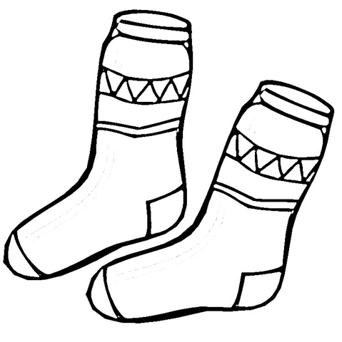

Our Student Council’s Socktober Sock Drive was quite a success. They collected 531 pairs of socks!! These socks have been donated to Housing Forward, a local homeless shelter, where they will be distributed. Many thanks for the support from our Whittier families!!

T.E.A.M. Report

Mrs. Hoehne’s Newsletter nhoehne@op97.org November 9, 2018